 ADDISON

Flame Retardant CAT5e CWB/SWB/SWA Armoured Data Cables

FGD-CAT5e U/UTP4P24 cwb/swb/swa

FGD-CAT5e f/UTP4P24 cwb/swb/swa

FGD-CAT5e sf/FTP4P24 cwb/swb/swa
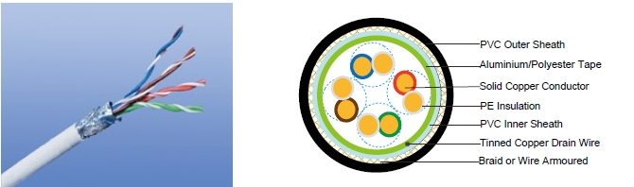

APPLICATION

Cat5E is a cable standard for Gigabit Ethernet and other network protocol, suitable for basic voice and data installations up to 100 MHz. In addition, these cables can be offered with copper wire braid armoured & flame retardant outer sheath, providing additional mechanically protection still maintaining the flexibility of the cable.

STANDARDS

Basic design adapted to EN50173

FIRE PERFORMANCE

Flame Retardance (Single Vertical EN 60332-1-2; IEC 60332-1-2; BS EN 60332-1-2; VDE _{Wire Test)**} 0482-332-1 ; NBN C 30-004 (cat. F1); NF C32-070-2.1(C2);
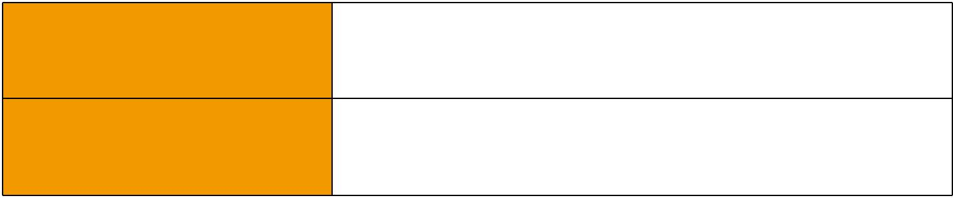
CEI 20-35/1-2; EN 50265-2-1*; DIN VDE 0482-265-2-1*

Reduced Fire Propagation | EN 60332-3-24 (cat. C); IEC 60332-3-24; BS EN 60332-3-24;
(Vertically-mounted bundled wires VDE 0482-332-3; NBN C 30-004 (cat. F2); NF C32-070-2.2(C1);
& cable test)** | CEI 20-22/3-4; EN 50266-2-4*; DIN VDE 0482-266-2-4

Note: Asterisk ** denotes that the standard compliance is optional, depending on the oxygen index of the PVC compound and the cable design.

VOLTAGE RATING

60V

CABLE CONSTRUCTION

Conductors: 24AWG solid bare copper.

Insulation: HDPE.

Twinning: Two coloured insulated conductors twisted together to form a pair.

Inner Sheath: Flame retardant, low smoke and halogen-free polyolefin, coloured black.

102 Caledonian


Caledonian

Flame Retardant Data Cables
www.caledonian-cables.co.uk www.addison-cables.com

Armouring:

cwb: copper Wire Braid swb: Steel Wire Braid swa: Steel Wire Armour

Outer Sheath: Thermoplastic PVC compound. UV resistance, hydrocarbon resistance, oil resistance, anti rodent and anti termite properties can be offered as option. Compliance to fire performance standard (IEC 60332-1, IEC 60332-3, UL 1581, UL 1666 etc) depends on the oxygen index of the PVC compound and the overall cable design. LSPVC can also be provided upon request.

Cat5E F/UTP: These cables have collective shielding of aluminium/Polyester tape with drain wire. Cat5E SF/UTP: These cables have double collective shieldings of aluminium/Polyester tape & copper wire braid.

Physical AND THERMAL PROPERTIES

Temperature range: -30°C ~ +75°C

Minimum bending radius during installation (mobile state): 8 x Overall Diameter

Minimum bending radius during operation (fixed state):4 x Overall Diameter

Electrical Properties

AWG |  | 24
Nominal Conductor Diameter | mm | 0.5/0.53
Maximum DC Resistant@20°C | Ω/100m | 9.38
Maximum DCR Unbalance | % | 5
Maximum Mutual Capacitance | pF/m | 55.8
Maximum Capacitance Unbalance | pF/100m | 330
Characteristic Impedance@1-100MHz | Ω | 100+/-15
Maximum Propagation Delay Skew | ns/100m | 45

Transmission Properties

FREQ | Maximum | Minimum | Minimum | Minimum | Minimum | Minimum
FREQ | Attenuation | NEXT | PSNEXT | ELFEXT | PSELFEXT | RL
MHz
MHz | dB/100m | dB | dB | dB/100m | dB/100m | dB
0.772 | 1.8 | 67.0 | 64.0 | 66.0 | 63.0 | —
1 | 2.0 | 65.3 | 62.3 | 63.8 | 60.8 | 20.0
4 | 4.1 | 56.3 | 53.3 | 51.7 | 48.7 | 23.0
8 | 5.8 | 51.8 | 48.8 | 45.7 | 42.7 | 24.5
10 | 6.5 | 50.3 | 47.3 | 43.8 | 40.8 | 25.0
16 | 8.2 | 47.3 | 44.3 | 39.7 | 36.7 | 25.0
20 | 9.3 | 45.8 | 42.8 | 37.7 | 34.7 | 25.0
25 | 10.4 | 44.3 | 41.3 | 35.8 | 32.8 | 24.3
31.25 | 11.7 | 42.9 | 39.9 | 33.9 | 30.9 | 23.6
62.5 | 17.0 | 38.4 | 35.4 | 27.8 | 24.8 | 21.5
100 | 22.0 | 35.3 | 32.3 | 23.8 | 20.8 | 20.1

 ADDISON 103

ADDISON

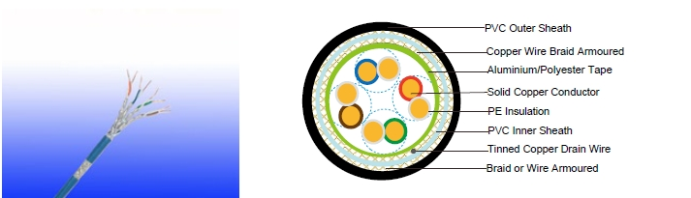

FGD Cat5E SF/UTP

CONSTRUCTION PARAMETERS

 |  |  |  |  |  |  | Construction
 |  |  |  |  |  |  | No. of |  |  |  | Nominal |  |  | Nominal |  | Nominal | Nominal
 |  |  |  |  |  |  | elements×No. |  |  |  |  |  |  | Inner |  | Outer | Nominal | Nominal
 | Cable Code |  |  |  |  |  | of cores in |  |  |  | Insulation |  |  | Sheath |  | Sheath | Overall | Weight
 |  |  |  |  |  |  | element×Conductor |  |  |  | Thickness |  |  | Thickness |  | Thickness | Diameter
 |  |  |  |  |  |  | diameter
 |  |  |  |  |  |  | mm |  |  |  |  | mm |  | mm |  | mm | mm | kg/km
FGD-CAT5e U/UTP CWB |  |  |  |  |  |  | 4×2×0.5 |  |  |  | 0.2 |  |  | 0.6 |  | 1.0 | 7.68 | 97
FGD-CAT5e U/UTP SWB |  |  |  |  |  |  | 4×2×0.5 |  |  |  | 0.2 |  |  | 0.6 |  | 1.0 | 7.68 | 93
FGD-CAT5e U/UTP SWA |  |  |  |  |  |  | 4×2×0.5 |  |  |  | 0.2 |  |  | 0.6 |  | 1.0 | 8.68 | 165
FGD-CAT5e F/UTP CWB |  |  |  |  |  |  | 4×2×0.53 |  |  |  | 0.2 |  |  | 0.6 |  | 1.0 | 8.28 | 116
FGD-CAT5e F/UTP SWB |  |  |  |  |  |  | 4×2×0.53 |  |  |  | 0.2 |  |  | 0.6 |  | 1.0 | 8.28 | 112
FGD-CAT5e F/UTP SWA |  |  |  |  |  |  | 4×2×0.53 |  |  |  | 0.2 |  |  | 0.6 |  | 1.0 | 9.28 | 192
FGD-CAT5e SF/UTP CWB |  |  |  |  |  |  | 4×2×0.53 |  |  |  | 0.2 |  |  | 0.6 |  | 1.0 | 8.76 | 123
FGD-CAT5e SF/UTP SWB |  |  |  |  |  |  | 4×2×0.53 |  |  |  | 0.2 |  |  | 0.6 |  | 1.0 | 8.76 | 119
FGD-CAT5e SF/UTP SWA |  |  |  |  |  |  | 4×2×0.53 |  |  |  | 0.2 |  |  | 0.6 |  | 1.0 | 9.76 | 216
 | 60V |  |  |  | _{N}EN50173
 |  |  |  |  | _{N}EN50173 |  | Flame Retardancy** |  |  | Reduced |  | Fire Propagation**
Rated Voltage |  |  |  |  |  |  | NF C32-070-2.1(C2) |  |  | NF C32-070-2.2(C1)
 |  |  |  |  | Standard |  | IEC60332-1-2/EN50265-2-1 |  |  | IEC60332-3-24/EN50266-2-4
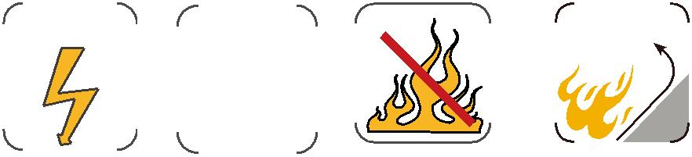

104 Caledonian

