
Caledonian

Flame Retardant Data Cables
www.caledonian-cables.co.uk www.addison-cables.com

Flame Retardant CAT6 Data Cables

FGD-CAT6 U/UTP4P23

FGD-CAT6 F/UTP4P23

FGD-CAT6 SF/FTP4P23
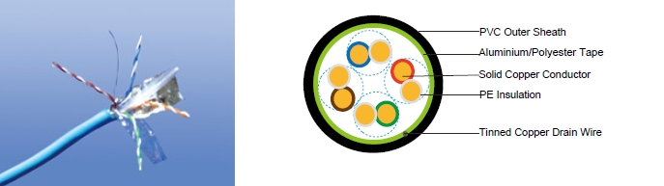

APPLICATION

Cat6 Cable is a cable standard for Gigabit Ethernet and other network protocol, suitable for 10BaseT, 100BaseTx & 1000BaseT (Gigabit Ethernet) application. In addition, these cables can be offered with copper wire braid armoured & flame retardant outer sheath, providing additional mechanically protection still maintaining the flexibility of the cable.

STANDARDS

Basic design adapted to EN50173

FIRE PERFORMANCE

Flame Retardance (Single Vertical EN 60332-1-2; IEC 60332-1-2; BS EN 60332-1-2; VDE _{Wire Test)**} 0482-332-1 ; NBN C 30-004 (cat. F1); NF C32-070-2.1(C2);
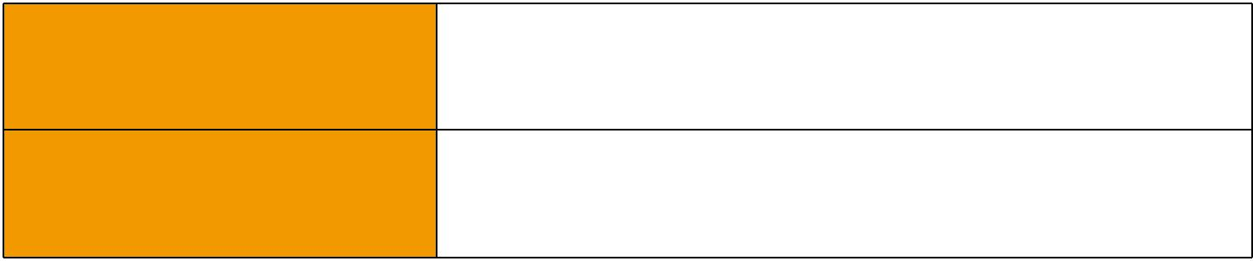
CEI 20-35/1-2; EN 50265-2-1*; DIN VDE 0482-265-2-1*

Reduced Fire Propagation | EN 60332-3-24 (cat. C); IEC 60332-3-24; BS EN 60332-3-24;
(Vertically-mounted bundled wires VDE 0482-332-3; NBN C 30-004 (cat. F2); NF C32-070-2.2(C1);
& cable test)** | CEI 20-22/3-4; EN 50266-2-4*; DIN VDE 0482-266-2-4

Note: Asterisk ** denotes that the standard compliance is optional, depending on the oxygen index of the PVC compound and the cable design.

VOLTAGE RATING

60V

CABLE CONSTRUCTION

Conductors: 23AWG solid bare copper.

Insulation: HDPE.

 ADDISON 105

 ADDISON

Twinning: Two coloured insulated conductors twisted together to form a pair.

Outer Sheath: Thermoplastic PVC compound. UV resistance, hydrocarbon resistance, oil resistance, anti rodent and anti termite properties can be offered as option. Compliance to fire performance standard (IEC 60332-1, IEC 60332-3, UL 1581, UL 1666 etc) depends on the oxygen index of the PVC compound and the overall cable design. LSPVC can also be provided upon request.

Cat6 F/UTP: These cables have collective shielding of aluminium/Polyester tape with drain wire. Cat6 SF/UTP: These cables have double collective shieldings of aluminium/Polyester tape & copper wire braid with drain wire.

Physical AND THERMAL PROPERTIES

Temperature range: -30°C ~ +75°C

Minimum bending radius during installation (mobile state): 8 x Overall Diameter

Minimum bending radius during operation (fixed state):4 x Overall Diameter

Electrical Properties

AWG |  | 23
Nominal Conductor Diameter | mm | 0.56/0.57/0.58
Maximum DC Resistant@20°C | Ω/100m | 9.38
Maximum DCR Unbalance | % | 3
Maximum Mutual Capacitance | pF/m | 5.8
Maximum Capacitance Unbalance | pF/100m | 30
Characteristic Impedance@1-100MHz | Ω | 100+/-15
Maximum Propagation Delay Skew | ns/100m | 18

Transmission Properties

FREQ | Maximum | Minimum | Minimum | Minimum | Minimum | Minimum
FREQ | Attenuation | NEXT | PSNEXT | ELFEXT | PSELFEXT | RL
MHz
MHz | dB/100m | dB | dB | dB/100m | dB/100m | dB
0.772 | 1.8 | 76.0 | 74. | 70.0 | 67.0 | —
1 | 2.0 | 74.3 | 72.3 | 67.8 | 64.8 | 20.0
4 | 3.8 | 65.3 | 63.3 | 55.7 | 52.7 | 23.0
8 | 5.3 | 60.8 | 58.8 | 49.7 | 46.7 | 24.5
10 | 6.0 | 59.3 | 57.3 | 47.8 | 44.8 | 25.0
16 | 7.6 | 56.3 | 54.3 | 43.7 | 40.7 | 25.0
20 | 8.5 | 54.8 | 52.8 | 41.7 | 38.7 | 25.0
25 | 9.5 | 53.3 | 51.3 | 39.8 | 36.8 | 24.3
31.25 | 10.7 | 51.9 | 49.9 | 37.9 | 34.9 | 23.6
62.5 | 15.4 | 47.4 | 45.4 | 31.8 | 28.8 | 21.5
100 | 19.8 | 44.3 | 42.3 | 27.8 | 24.8 | 20.1

106 Caledonian

Caledonian

Flame Retardant Data Cables
www.caledonian-cables.co.uk www.addison-cables.com


FREQ | Maximum | Minimum | Minimum | Minimum | Minimum | Minimum
FREQ | Attenuation | NEXT | PSNEXT | ELFEXT | PSELFEXT | RL
MHz
MHz | dB/100m | dB | dB | dB/100m | dB/100m | dB
155 | 25.2 | 41.5 | 39.5 | 23.9 | 20.9 | 18.8
200 | 29.0 | 39.8 | 37.8 | 21.7 | 18.7 | 18.0
250 | 32.8 | 38.3 | 36.3 | 19.8 | 16.8 | 17.3

CONSTRUCTION PARAMETERS
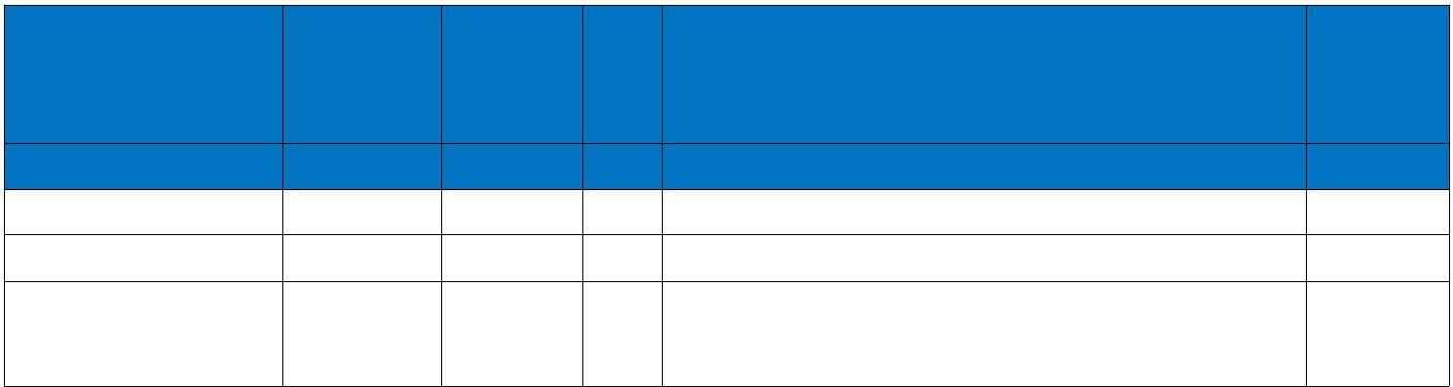
Cable Code | Conductor ^{Diameter} |  |  |  | Overall
Cable Code |  | Over | Pairs | Screen
 | ^{Diameter} Insulation |  |  |  | Diameter
 | mm | mm |  |  | mm
FGD-Cat6 U/UTP | 0.56/0.57 | 1.02 | 4 | Nil | 6.0
FGD-Cat6 F/UTP | 0.57/0.58 | 1.02 | 4 | Overall Aluminum Tape Screen | 6.3
FGD-Cat6 SF/UTP 0.57/0.58 |  | 1.02 | 4 | Overall Aluminum Tape Screen & | 6.6
 |  | 1.02 | 4 | Copper Wire Braid | 6.6
60V | _{N}EN50173 | Flame Retardancy** |  | Reduced Fire Propagation**
Rated Voltage |  | NF C32-070-2.1(C2) |  | NF C32-070-2.2(C1)
Rated Voltage | Standard | IEC60332-1-2/EN50265-2-1 |  | IEC60332-3-24/EN50266-2-4
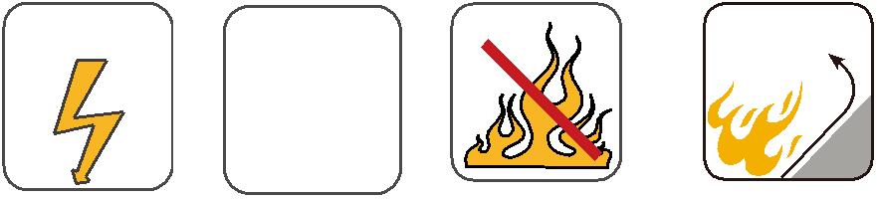

ADDISON 107

