 ADDISON

Flame Retardant CAT6 CWB/SWB/SWA Armoured Data Cables

FGD-CAT6 U/UTP4P23 cwb/swb/swa

FGD-CAT6 F/UTP4P23 cwb/swb/swa

FGD-CAT6 SF/UTP4P23 cwb/swb/swa
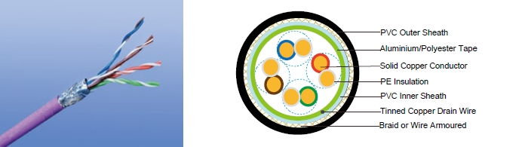

APPLICATION

Cat6 Cable is a cable standard for Gigabit Ethernet and other network protocol, suitable for 10BaseT, 100BaseTx & 1000BaseT (Gigabit Ethernet) application. In addition, these cables can be offered with copper wire braid armoured & flame retardant outer sheath, providing additional mechanically protection still maintaining the flexibility of the cable.

STANDARDS

Basic design adapted to EN50173

FIRE PERFORMANCE

Flame Retardance (Single Vertical EN 60332-1-2; IEC 60332-1-2; BS EN 60332-1-2; VDE _{Wire Test)**} 0482-332-1 ; NBN C 30-004 (cat. F1); NF C32-070-2.1(C2);
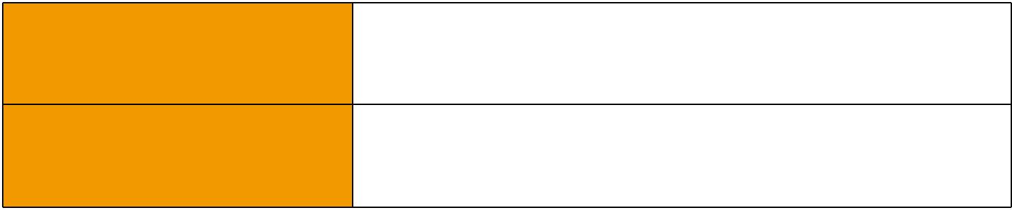
CEI 20-35/1-2; EN 50265-2-1*; DIN VDE 0482-265-2-1*

Reduced Fire Propagation | EN 60332-3-24 (cat. C); IEC 60332-3-24; BS EN 60332-3-24;
(Vertically-mounted bundled wires VDE 0482-332-3; NBN C 30-004 (cat. F2); NF C32-070-2.2(C1);
& cable test)** | CEI 20-22/3-4; EN 50266-2-4*; DIN VDE 0482-266-2-4

Note: Asterisk ** denotes that the standard compliance is optional, depending on the oxygen index of the PVC compound and the cable design.

VOLTAGE RATING

60V

CABLE CONSTRUCTION

Conductors: 23AWG solid bare copper.

Insulation: HDPE .

Twinning: Two coloured insulated conductors twisted together to form a pair.

Inner Sheath: Flame retardant, low smoke and halogen-free polyolefin, coloured black.

Armouring:

108 Caledonian


Caledonian

Flame Retardant Data Cables
www.caledonian-cables.co.uk www.addison-cables.com

cwb: copper Wire Braid swb: Steel Wire Braid swa: Steel Wire Armour

Outer Sheath: Thermoplastic PVC compound. UV resistance, hydrocarbon resistance, oil resistance, anti rodent and anti termite properties can be offered as option. Compliance to fire performance standard (IEC 60332-1, IEC 60332-3, UL 1581, UL 1666 etc) depends on the oxygen index of the PVC compound and the overall cable design. LSPVC can also be provided upon request.

Cat6 F/UTP: These cables have collective shielding of aluminium/Polyester tape with drain wire. Cat6 SF/UTP: These cables have double collective shieldings of aluminium/Polyester tape & copper wire braid with drain wire.

Physical AND THERMAL PROPERTIES

Temperature range: -30°C ~ +75°C

Minimum bending radius during installation (mobile state): 8 x Overall Diameter

Minimum bending radius during operation (fixed state):4 x Overall Diameter

Electrical Properties

AWG |  | 23
Nominal Conductor Diameter | mm | 0.56/0.57/0.58
Maximum DC Resistant@20°C | Ω/100m | 9.38
Maximum DCR Unbalance | % | 3
Maximum Mutual Capacitance | pF/m | 5.8
Maximum Capacitance Unbalance | pF/100m | 30
Characteristic Impedance@1-100MHz | Ω | 100+/-15
Maximum Propagation Delay Skew | ns/100m | 18

Transmission Properties

FREQ | Maximum | Minimum | Minimum | Minimum | Minimum | Minimum
FREQ | Attenuation | NEXT | PSNEXT | ELFEXT | PSELFEXT | RL
MHz
MHz | dB/100m | dB | dB | dB/100m | dB/100m | dB
0.772 | 1.8 | 76.0 | 74. | 70.0 | 67.0 | —
1 | 2.0 | 74.3 | 72.3 | 67.8 | 64.8 | 20.0
4 | 3.8 | 65.3 | 63.3 | 55.7 | 52.7 | 23.0
8 | 5.3 | 60.8 | 58.8 | 49.7 | 46.7 | 24.5
10 | 6.0 | 59.3 | 57.3 | 47.8 | 44.8 | 25.0
16 | 7.6 | 56.3 | 54.3 | 43.7 | 40.7 | 25.0
20 | 8.5 | 54.8 | 52.8 | 41.7 | 38.7 | 25.0
25 | 9.5 | 53.3 | 51.3 | 39.8 | 36.8 | 24.3
31.25 | 10.7 | 51.9 | 49.9 | 37.9 | 34.9 | 23.6
62.5 | 15.4 | 47.4 | 45.4 | 31.8 | 28.8 | 21.5
100 | 19.8 | 44.3 | 42.3 | 27.8 | 24.8 | 20.1
155 | 25.2 | 41.5 | 39.5 | 23.9 | 20.9 | 18.8
200 | 29.0 | 39.8 | 37.8 | 21.7 | 18.7 | 18.0

 ADDISON 109

ADDISON


 |  | FREQ |  |  | Maximum |  |  |  |  |  | Minimum |  |  |  | Minimum |  |  |  | Minimum |  |  |  | Minimum |  | Minimum
 |  |  |  |  | Attenuation |  |  |  |  |  | NEXT |  |  |  | PSNEXT |  |  |  | ELFEXT |  |  |  | PSELFEXT |  |  | RL
 |  | MHz |  |  |  |  |  |  |  |  |  |  |  |  |  |  |  |  |  |  |  |  |  |  |  | RL
 |  |  |  |  |  |  | dB/100m |  |  |  | dB |  |  |  | dB |  |  |  | dB/100m |  |  |  | dB/100m |  |  | dB
250 |  |  |  |  | 32.8 |  |  |  |  |  | 38.3 |  |  |  | 36.3 |  |  |  | 19.8 |  |  |  | 16.8 |  |  | 17.3
 |  |  |  |  |  |  |  |  |  |  |  |  |  |  |  |  |  |  | PVC Outer Sheath
 |  |  |  |  |  |  |  |  |  |  |  |  |  |  |  |  |  |  | Copper Wire Braid Armoured
 |  |  |  |  |  |  |  |  |  |  |  |  |  |  |  |  |  |  | Aluminium/Polyester Tape
 |  |  |  |  |  |  |  |  |  |  |  |  |  |  |  |  |  |  | Solid Copper Conductor
 |  |  |  |  |  |  |  |  |  |  |  |  |  |  |  |  |  |  | PE Insulation
 |  |  |  |  |  |  |  |  |  |  |  |  |  |  |  |  |  |  | PVC Inner Sheath
 |  |  |  |  |  |  |  |  |  |  |  |  |  |  |  |  |  |  | Tinned Copper Drain Wire
 |  |  |  |  |  |  |  |  |  |  |  |  |  |  |  |  |  |  | Braid or Wire Armoured
 |  |  |  |  |  |  |  |  |  | FGD Cat6 SF/UTP
CONSTRUCTION PARAMETERS
 |  |  |  |  |  |  |  |  |  | Construction |  |  |  |  |  |  |  |  | Nominal |  |  | Nominal
 |  |  |  |  |  |  |  | No. of elements×No. |  |  |  |  |  |  | Nominal |  |  |  |  |  |  |  |  | Nominal
 |  | Cable Code |  |  |  |  |  |  |  | of cores in |  |  |  |  | Insulation |  |  |  | Inner |  |  | Outer |  | Overall |  | Nominal
 |  |  |  |  |  |  |  |  | element×Conductor |  |  |  |  |  | Thickness |  |  |  | Sheath |  |  | Sheath |  | Diameter |  | Weight
 |  |  |  |  |  |  |  |  |  |  |  |  |  |  |  |  |  | Thickness |  |  | Thickness
 |  |  |  |  |  |  |  |  |  | diameter
 |  |  |  |  |  |  |  |  |  | mm |  |  |  |  |  |  | mm |  | mm |  |  | mm |  | mm |  | kg/km
FGD-CAT6 U/UTP CWB |  |  |  |  |  |  |  |  |  | 4×2×0.56/0.57 |  |  |  |  | 0.2 |  |  |  | 0.6 |  |  | 1.0 |  | 7.88 |  | 115
FGD-CAT6 U/UTP SWB |  |  |  |  |  |  |  |  |  | 4×2×0.56/0.57 |  |  |  |  | 0.2 |  |  |  | 0.6 |  |  | 1.0 |  | 7.88 |  | 109
FGD-CAT6 U/UTP SWA |  |  |  |  |  |  |  |  |  | 4×2×0.56/0.57 |  |  |  |  | 0.2 |  |  |  | 0.6 |  |  | 1.0 |  | 8.88 |  | 189
FGD-CAT6 F/UTP CWB |  |  |  |  |  |  |  |  |  | 4×2×0.57/0.58 |  |  |  |  | 0.2 |  |  |  | 0.6 |  |  | 1.0 |  | 8.48 |  | 126
FGD-CAT6 F/UTP SWB |  |  |  |  |  |  |  |  |  | 4×2×0.57/0.58 |  |  |  |  | 0.2 |  |  |  | 0.6 |  |  | 1.0 |  | 8.48 |  | 132
FGD-CAT6 F/UTP SWA |  |  |  |  |  |  |  |  |  | 4×2×0.57/0.58 |  |  |  |  | 0.2 |  |  |  | 0.6 |  |  | 1.0 |  | 9.48 |  | 213
FGD-CAT6 SF/UTP CWB |  |  |  |  |  |  |  |  |  | 4×2×0.57/0.58 |  |  |  |  | 0.2 |  |  |  | 0.6 |  |  | 1.0 |  | 8.96 |  | 154
FGD-CAT6 SF/UTP SWB |  |  |  |  |  |  |  |  |  | 4×2×0.57/0.58 |  |  |  |  | 0.2 |  |  |  | 0.6 |  |  | 1.0 |  | 8.96 |  | 148
FGD-CAT6 SF/UTP SWA |  |  |  |  |  |  |  |  |  | 4×2×0.57/0.58 |  |  |  |  | 0.2 |  |  |  | 0.6 |  |  | 1.0 |  | 9.96 |  | 242
 |  | 60V |  |  |  |  | _{N}EN50173
 |  |  |  |  |  |  |  |  |  | Flame Retardancy** |  |  |  |  | Reduced |  | Fire Propagation**
Rated Voltage |  |  |  |  |  |  |  |  |  | NF C32-070-2.1(C2) |  |  |  |  | NF C32-070-2.2(C1)
 |  |  |  |  |  |  | Standard |  |  | IEC60332-1-2/EN50265-2-1 |  |  |  |  | IEC60332-3-24/EN50266-2-4
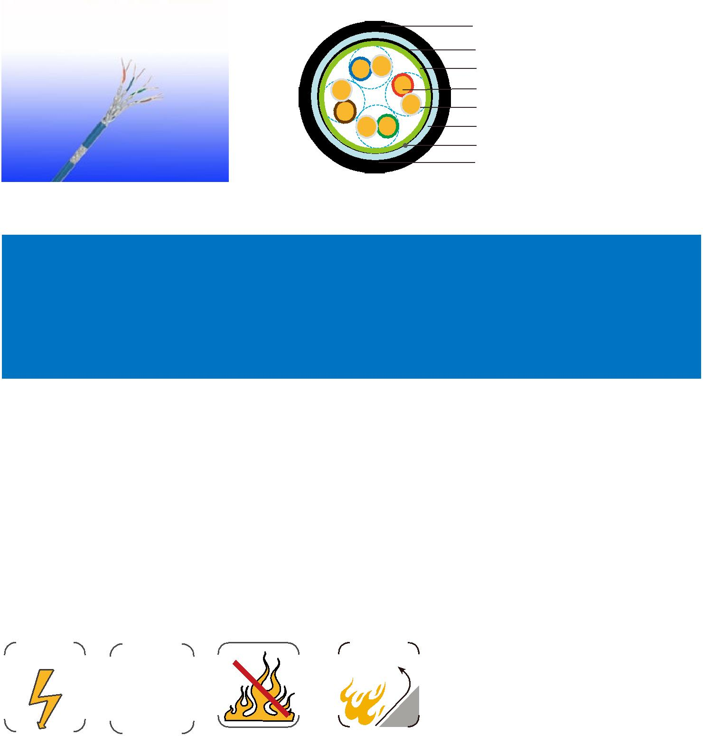

110 Caledonian

