
Caledonian

Flame Retardant Power & Control Cables

www.caledonian-cables.co.uk www.addison-cables.com

600/1000V PVC Insulated, Non-sheathed Power Cables (Single Core)

FGD300 1V-R (CU/PVC 600/1000V Class 2)
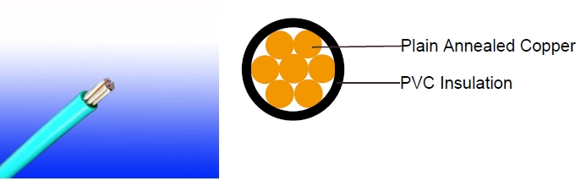

APPLICATION

The cables are mainly used in power stations, mass transit underground passenger systems, airports, petrochemical plants, hotels, hospitals, and high-rise buildings.

STANDARDS

Basic design adapted to BS 6491X

FIRE PERFORMANCE

Flame Retardance (Single Vertical EN 60332-1-2; IEC 60332-1-2; BS EN 60332-1-2; VDE _{Wire Test)**} 0482-332-1 ; NBN C 30-004 (cat. F1); NF C32-070-2.1(C2);
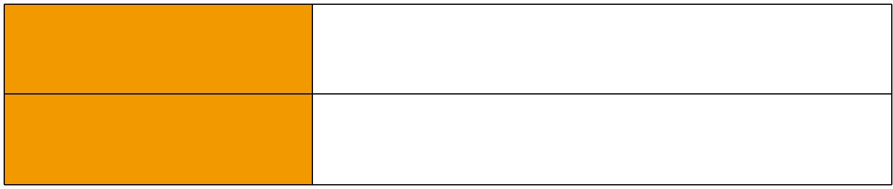
CEI 20-35/1-2; EN 50265-2-1*; DIN VDE 0482-265-2-1*

Reduced Fire Propagation | EN 60332-3-24 (cat. C); IEC 60332-3-24; BS EN 60332-3-24;
(Vertically-mounted bundled wires VDE 0482-332-3; NBN C 30-004 (cat. F2); NF C32-070-2.2(C1);
& cable test)** | CEI 20-22/3-4; EN 50266-2-4*; DIN VDE 0482-266-2-4

Note: Asterisk ** denotes that the standard compliance is optional, depending on the oxygen index of the PVC compound and the cable design.

VOLTAGE RATING

600/1000V

CABLE CONSTRUCTION

Conductor: Plain annealed copper wire, stranded according to IEC(EN) 60228 class 2.

Insulation: Thermoplastic PVC compound. UV resistance, hydrocarbon resistance, oil resistance, anti rodent and anti termite properties can be offered as option. Compliance to fire performance standard (IEC 60332-1, IEC 60332-3, UL 1581, UL 1666 etc) depends on the oxygen index of the PVC compound and the overall cable design. LSPVC can also be provided upon request.

 ADDISON 33

 ADDISON

COLOUR CODE

Insulation Colour as per BS7671
 | With Earth Conductor | Without Earth Conductor
2Cores | - | Brown, Blue
3Cores | Yellow/Green, Brown, Blue | Brown, Gray, Black
4Cores | Yellow/Green, Brown, Gray, Black | Brown, Gray, Black, Blue
5Cores | Yellow/Green, Brown, Gray, Black, Blue | Brown, Gray, Black, Blue, Black
Above 5 Cores | Yellow/Green, Black Numbered | Black Numbered

Sheath Colour: Black (other colors upon request)

Physical AND THERMAL PROPERTIES

Temperature range during operation: Max.90°C

250°C in short-circuit for 5secs max. Minimum bending radius: 8 x Overall Diameter (unarmoured cable)

10 x Overall Diameter (armoured cable)

CONSTRUCTION PARAMETERS

Conductor |  |  |  | FGD300 1V-R
No. of Core X |  | No./Nominal | Nominal |  | Insulated, Non-Sheathed
No. of Core X |  | Diameter of | Insulation |  | Nominal | Approx.
Cross Section |  | Diameter of | Insulation |  | Nominal | Approx.
Cross Section |  | Strands | Thickness |  | Overall | Approx.
 |  | Strands | Thickness |  | Overall | Weight
 |  |  |  |  | Diameter | Weight
Noxmm² |  | No./mm | mm |  | mm | kg/km
1x1.5 |  | 7/0.53 | 0.7 |  | 3.1 | 22
1x2.5 |  | 7/0.67 | 0.8 |  | 3.7 | 34
1x4 |  | 7/0.85 | 0.8 |  | 4.3 | 50
1x6 |  | 7/1.04 | 0.8 |  | 4.8 | 70
1x10 |  | 7/1.35 | 1.0 |  | 6.2 | 116
1x16 |  | 7/1.70 | 1.0 |  | 7.2 | 174
1x25 |  | 7/2.14 | 1.2 |  | 9.0 | 276
1x35 |  | 7/2.52 | 1.2 |  | 10.0 | 366
1x50 |  | 19/1.78 | 1.4 |  | 11.9 | 502
1x70 |  | 19/2.14 | 1.4 |  | 13.7 | 706
1x95 |  | 19/2.52 | 1.6 |  | 16.0 | 974
1x120 |  | 37/2.03 | 1.6 |  | 17.6 | 1213
1x150 |  | 37/2.25 | 1.8 |  | 19.6 | 1492
1x185 |  | 37/2.52 | 2.0 |  | 21.8 | 1868
1x240 |  | 61/2.25 | 2.2 |  | 24.4 | 2443
1x300 |  | 61/2.52 | 2.4 |  | 27.7 | 3055
1x400 |  | 61/2.85 | 2.6 |  | 31.1 | 3888

34 Caledonian

Caledonian

Flame Retardant Power & Control Cables

www.caledonian-cables.co.uk www.addison-cables.com

1x500 | 61/3.20 | 2.8 | 34.6 | 4880
1x630 | 127/2.52 | 2.8 | 38.6 | 6229

Electrical PROPERTIES

Conductor Operating Temperature : 90°C

Ambient Temperature : 30°C

Current-Carrying Capacities (Amp)

 | Reference Method |  | Reference |  |  |  | Reference |  | Reference Method 12 (free
Conductor |  |  | Method 3
cross- | 4 (enclosed |  | (enclosed in |  | Reference Method |  | Method 11 (on a |  |  | air)
cross- | in conduit |  |  |  |  |  | perforated cable
 |  |  |  |  |  |  |  |  | Horizontal | Vertical
sectional | in thermally |  | conduit on |  | 1 (clipped direct) |  | tray, horizontal or |  | Horizontal | Vertical
area | insulating wall etc) |  | a wall or in |  |  |  | vertical) |  | flat | flat | Trefoil
 |  |  | trunking etc) |  |  |  |  |  | spaced | spaced
 |  |  |  |  |  |  |  |  | 2 cables, | 2 cables,
 |  |  |  |  | 2 cables, | 3 or 4 | 2 cables, | 3 or 4 | 2 cables, | single-
 | 2 |  | 2 |  | single- | cables, | single- | cables, | single- | phase
 | cables, | 3 or 4 | cables, | 3 or 4 |  |  |  |  | phase | phase | 3 cables,
 |  |  |  |  | phase | 3-phase | phase | 3-phase | phase | a.c. or | 3 cables,
 | single- | cables, | single- | cables, | a.c. or | a.c. flat | a.c. or | a.c. flat | a.c. or | d.c. | trefoil
 | phase | 3-phase | phase | 3-phase |  |  |  |  | d.c. | d.c. | 3-phase
 | a.c. or | a.c. | a.c. or | a.c. | d.c. flat | and | d.c. or | and | or 3 c | or 3 | a.c.
 | d.c. |  | d.c |  | and | touching | flat and | touching | ables three | cables
 | d.c. |  | d.c |  | touching | or trefoil | touching | or trefoil | ables three | three
 |  |  |  |  |  |  |  |  | phase | phase
1 | 2 | 3 | 4 | 5 | 6 | 7 | 8 | 9 | 10 | 11 | 12
mm² | A | A | A | A | A | A | A | A | A | A | A
1.5 | 18 | 17 | 22 | 19 | 25 | 23 | - | - | - | - | -
2.5 | 24 | 23 | 30 | 26 | 34 | 31 | - | - | - | - | -
4 | 33 | 30 | 40 | 35 | 46 | 41 | - | - | - | - | -
6 | 43 | 39 | 51 | 45 | 59 | 54 | - | - | - | - | -
10 | 58 | 53 | 71 | 63 | 81 | 74 | - | - | - | - | -
16 | 76 | 70 | 95 | 85 | 109 | 99 | - | - | - | - | -
25 | 100 | 91 | 126 | 111 | 143 | 130 | 158 | 140 | 183 | 163 | 138
35 | 125 | 111 | 156 | 138 | 176 | 161 | 195 | 176 | 226 | 203 | 171
50 | 149 | 135 | 189 | 168 | 228 | 209 | 293 | 215 | 274 | 246 | 209
70 | 189 | 170 | 240 | 214 | 293 | 268 | 308 | 279 | 351 | 318 | 270
95 | 228 | 205 | 290 | 259 | 355 | 326 | 375 | 341 | 426 | 389 | 330
120 | 263 | 235 | 336 | 299 | 413 | 379 | 436 | 398 | 495 | 453 | 385
150 | 300 | 270 | 375 | 328 | 476 | 436 | 505 | 461 | 570 | 524 | 445
185 | 341 | 306 | 426 | 370 | 545 | 500 | 579 | 530 | 651 | 600 | 511
240 | 400 | 358 | 500 | 433 | 644 | 590 | 686 | 630 | 769 | 711 | 606
300 | 459 | 410 | 573 | 493 | 743 | 681 | 794 | 730 | 886 | 824 | 701

ADDISON 35

ADDISON

400 | - | - | 684 | 584 | 868 | 793 | 915 | 849 | 1065 | 994 | 820
500 | - | - | 783 | 666 | 990 | 904 | 1044 | 973 | 1228 | 1150 | 936
630 | - | - | 900 | 764 | 1130 | 1033 | 1191 | 1115 | 1423 | 1338 | 1069

Voltage Drop (Per Amp Per Meter)

 |  |  | 2 cables, single-phase a.c. |  |  |  |  |  |  |  |  |  |  |  |  |  | 3 or 4 cables, 3-phase a.c.
Size of | 2 | Ref. Methods 3 |  |  |  |  |  |  | Ref. Methods 1 |  |  |  |  | Ref. Methods 3 |  |  |  | Ref. Methods 1, |  |  | Ref. Methods 1
Size of | cables | and 4 (enclosed |  |  |  |  |  |  | and 11 (clipped |  |  |  |  | and 4 (enclosed
conductor |  |  |  |  |  |  |  |  |  |  |  |  |  |  |  |  |  | 11 and 12 (in |  |  | and 11
 | d.c. | in conduit etc, in |  |  |  |  |  |  | direct or on trays |  |  |  |  | in conduit etc, in |  |  |  |  | trefoil) |  | (Flat and touching)
 |  |  | or on a wall) |  |  |  |  |  | touching) |  |  |  |  | or on a wall)
1 | 2 |  |  | 3 |  |  |  |  | 4 |  |  |  |  |  | 5 |  |  |  | 6 |  | 7
mm² | mV/A/m |  | mV/A/m |  |  |  |  |  | mV/A/m |  |  |  |  | mV/A/m |  |  |  | mV/A/m |  |  | mV/A/m
1.5 | 31 |  |  | 31 |  |  |  |  | 27 |  |  |  |  |  | 27 |  |  |  | 27 |  | 27
2.5 | 19 |  |  | 19 |  |  |  |  | 16 |  |  |  |  |  | 16 |  |  |  | 16 |  | 16
4 | 33 |  |  | 12 |  |  |  |  | 10 |  |  |  |  |  | 10 |  |  |  | 10 |  | 10
6 | 7.8 |  |  | 7.9 |  |  |  |  | 6.8 |  |  |  |  |  | 6.8 |  |  |  | 6.8 |  | 6.8
10 | 4.7 |  |  | 4.7 |  |  |  |  | 4.7 |  |  |  |  |  | 4 |  |  |  | 4 |  | 4
16 | 2.9 |  |  | 2.9 |  |  |  |  | 2.9 |  |  |  |  |  | 2.5 |  |  |  | 2.5 |  | 2.5
 |  |  | r | x |  | z |  |  | r | x |  | z |  | r | x |  | z | r | x | z | r | x | z
25 | 1.85 | 1.85 |  | 0.31 |  | 1.90 |  |  | 1.85 | 0.190 |  | 1.85 |  | 1.60 | 0.27 |  | 1.65 | 1.600 | 0.165 | 1.600 | 1.600 | 0.190 | 1.600
35 | 1.35 | 1.35 |  | 0.29 |  | 1.35 |  |  | 1.35 | 0.180 |  | 1.35 |  | 1.15 | 0.25 |  | 1.15 | 1.150 | 0.155 | 1.50 | 1.150 | 0.180 | 1.150
50 | 0.99 | 1.00 |  | 0.29 |  | 1.05 |  |  | 0.99 | 0.180 |  | 1.00 |  | 0.87 | 0.25 |  | 0.90 | 0.860 | 0.155 | 0.870 | 0.860 | 0.180 | 0.870
70 | 0.68 | 0.70 |  | 0.28 |  | 0.75 |  |  | 0.68 | 0.175 |  | 0.71 |  | 0.60 | 0.24 |  | 0.65 | 0.590 | 0.150 | 0.610 | 0.590 | 0.175 | 0.620
95 | 0.49 | 0.51 |  | 0.27 |  | 0.58 |  |  | 0.49 | 0.170 |  | 0.52 |  | 0.44 | 0.23 |  | 0.50 | 0.430 | 0.145 | 0.450 | 0.430 | 0.170 | 0.460
120 | 0.39 | 0.41 |  | 0.26 |  | 0.48 |  |  | 0.39 | 0.165 |  | 0.43 |  | 0.35 | 0.23 |  | 0.42 | 0.340 | 0.140 | 0.370 | 0.340 | 0.165 | 0.380
150 | 0.32 | 0.33 |  | 0.26 |  | 0.43 |  |  | 0.32 | 0.165 |  | 0.36 |  | 0.29 | 0.23 |  | 0.37 | 0.280 | 0.140 | 0.310 | 0.280 | 0.165 | 0.320
185 | 0.25 | 0.27 |  | 0.26 |  | 0.37 |  |  | 0.26 | 0.165 |  | 0.30 |  | 0.23 | 0.23 |  | 0.32 | 0.220 | 0.140 | 0.260 | 0.220 | 0.165 | 0.280
240 | 0.19 | 0.21 |  | 0.26 |  | 0.33 |  |  | 0.20 | 0.160 |  | 0.25 |  | 0.185 | 0.22 |  | 0.29 | 0.170 | 0.140 | 0.220 | 0.170 | 0.165 | 0.240
300 | 0.155 | 0.175 |  | 0.25 |  | 0.31 |  |  | 0.16 | 0.160 |  | 0.22 |  | 0.150 | 0.22 |  | 0.27 | 0.140 | 0.140 | 0.195 | 0.135 | 0.160 | 0.210
400 | 0.12 | 0.140 |  | 0.25 |  | 0.29 |  |  | 0.13 | 0.155 |  | 0.20 |  | 0.125 | 0.22 |  | 0.25 | 0.110 | 0.135 | 0.175 | 0.110 | 0.160 | 0.195
500 | 0.093 | 0.120 |  | 0.25 |  | 0.28 |  |  | 0.105 | 0.155 |  | 0.185 |  | 0.100 | 0.22 |  | 0.24 | 0.090 | 0.135 | 0.160 | 0.088 | 0.160 | 0.180
630 | 0.072 | 0.100 |  | 0.25 |  | 0.27 |  |  | 0.086 | 0.155 |  | 0.175 |  | 0.088 | 0.21 |  | 0.23 | 0.074 | 0.135 | 0.150 | 0.071 | 0.160 | 0.170
Note :
r = conductor resistance at operating temperature
x = reactance
z = impedance
600/1000V |  |  | _{N}BS6491X
 |  |  |  |  |  |  |  |  | Flame Retardancy** |  |  | Reduced Fire Propagation**
Rated Voltage |  |  |  |  |  | NF C32-070-2.1(C2) |  |  |  |  |  | NF C32-070-2.2(C1)
 |  |  | Standard |  |  | _{IEC60332-1-2/EN50265-2-1} IEC60332-3-24/EN50266-2-4
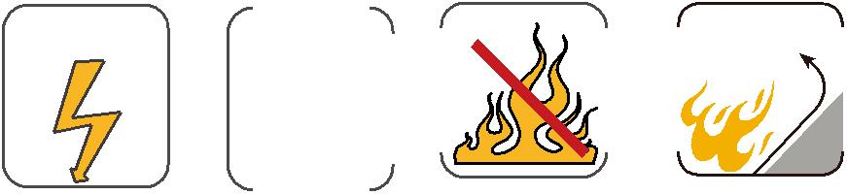

36 Caledonian

