
Caledonian

Flame Retardant Power & Control Cables

www.caledonian-cables.co.uk www.addison-cables.com

450/750V PVC Insulated, Non-sheathed Power Cables (Single Core)

FGD100 07V-R (CU/PVC 450/750V Class 2)
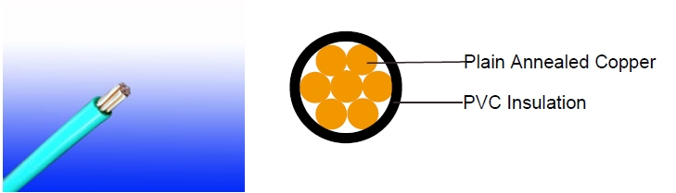

APPLICATION

This cables are mainly used in power stations, mass transit underground passenger systems, airports, petrochemical plants, hotels, hospitals, and high-rise buildings.

STANDARDS

Basic design adapted to BS 6491X

FIRE PERFORMANCE

Flame Retardance (Single Vertical EN 60332-1-2; IEC 60332-1-2; BS EN 60332-1-2; VDE _{Wire Test)**} 0482-332-1 ; NBN C 30-004 (cat. F1); NF C32-070-2.1(C2);
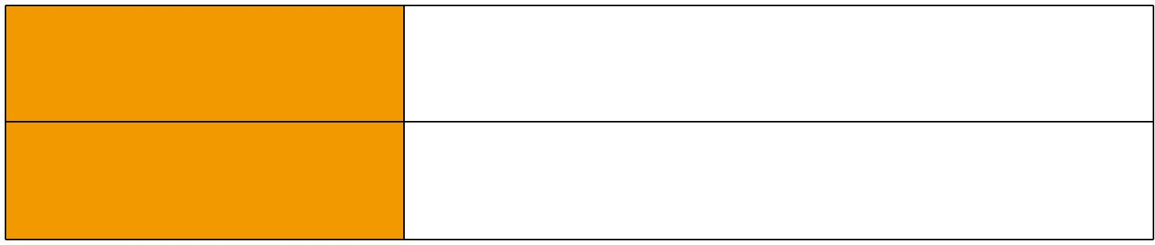
CEI 20-35/1-2; EN 50265-2-1*; DIN VDE 0482-265-2-1*

Reduced Fire Propagation | EN 60332-3-24 (cat. C); IEC 60332-3-24; BS EN 60332-3-24;
(Vertically-mounted bundled wires VDE 0482-332-3; NBN C 30-004 (cat. F2); NF C32-070-2.2(C1);
& cable test)** | CEI 20-22/3-4; EN 50266-2-4*; DIN VDE 0482-266-2-4

Note: Asterisk ** denotes that the standard compliance is optional, depending on the oxygen index of the PVC compound and the cable design.

VOLTAGE RATING

450/750V

CABLE CONSTRUCTION

Conductor: Plain annealed copper wire, stranded according to IEC(EN) 60228 class 2.

Insulation: Thermoplastic PVC compound. UV resistance, hydrocarbon resistance, oil resistance, anti rodent and anti termite properties can be offered as option. Compliance to fire performance standard (IEC 60332-1, IEC 60332-3, UL 1581, UL 1666 etc) depends on the oxygen index of the PVC compound and the overall cable design. LSPVC can also be provided upon request.

 ADDISON 17

 ADDISON

COLOUR CODE

Insulation Colour as per BS7671
 | With Earth Conductor | Without Earth Conductor
2Cores | - | Brown, Blue
3Cores | Yellow/Green, Brown, Blue | Brown, Gray, Black
4Cores | Yellow/Green, Brown, Gray, Black | Brown, Gray, Black, Blue
5Cores | Yellow/Green, Brown, Gray, Black, Blue | Brown, Gray, Black, Blue, Black
Above 5 Cores | Yellow/Green, Black Numbered | Black Numbered

Sheath Colour: Black (other colors upon request)

Physical AND THERMAL PROPERTIES

Temperature range during operation: Max.90°C

250°C in short-circuit for 5secs max.

Minimum bending radius: 6 x Overall Diameter

CONSTRUCTION PARAMETERS

Conductor |  |  | FGD100 07V-R
No. of Core X | No./Nominal | Nominal | Nominal
No. of Core X | Diameter of | Insulation | Overall | Approx. Weight
Cross Section
Cross Section | Strands | Thickness | Diameter
Noxmm² | No./mm | mm | mm | kg/km
1x1.5 | 7/0.53 | 0.7 | 3.1 | 23
1x2.5 | 7/0.67 | 0.8 | 3.7 | 35
1x4 | 7/0.85 | 0.8 | 4.3 | 52
1x6 | 7/1.04 | 0.8 | 4.8 | 73
1x10 | 7/1.35 | 1.0 | 6.2 | 120
1x16 | 7/1.70 | 1.0 | 7.2 | 180
1x25 | 7/2.24 | 1.2 | 9.0 | 285
1x35 | 19/1.53 | 1.2 | 10.2 | 375
1x50 | 19/1.78 | 1.4 | 12.0 | 510
1x70 | 19/2.14 | 1.4 | 14.0 | 720
1x95 | 19/2.52 | 1.6 | 16.0 | 995
1x120 | 37/2.03 | 1.6 | 18.0 | 1230
1x150 | 37/2.25 | 1.8 | 20.0 | 1520
1x185 | 37/2.52 | 2.0 | 22.0 | 1900
1x240 | 61/2.25 | 2.2 | 25.0 | 2480
1x300 | 61/2.52 | 2.4 | 28.0 | 3100
1x400 | 61.2.85 | 2.6 | 31.5 | 3950
1x500 | 61/3.20 | 2.8 | 35.0 | 4950
1x630 | 127/2.52 | 2.8 | 39.0 | 6360

18 Caledonian

Caledonian

Flame Retardant Power & Control Cables

www.caledonian-cables.co.uk www.addison-cables.com

Electrical PROPERTIES

Conductor Operating Temperature : 90°C

Ambient Temperature : 30°C

Current-Carrying Capacities (Amp)

 |  |  | Reference |  |  |  | Reference |  | Reference Method 12 (free
Conductor | Reference Method |  | Method 3
Conductor |  |  |  |  | Reference |  | Method 11 (on a |  |  | air)
cross- | 4 (enclosed in |  | (enclosed in |  |  |  |  |  |  | air)
cross- |  |  |  |  | Method 1 (clipped |  | perforated cable |  | Horizontal | Vertical
sectional | conduit in thermally |  | conduit on |  | direct) |  | tray, horizontal or |  | flat | flat | Trefoil
area | insulating wall etc) |  | a wall or in
area |  |  |  |  |  |  | vertical) |  | spaced | spaced
 |  |  | trunking etc) |  |  |  |  |  | spaced | spaced
 |  |  |  |  |  |  | 2 |  | 2 cables, | 2 cables,
 |  |  |  |  | 2 cables, | 3 or 4 | 2 | 3 or 4 | single- | single-
 | 2 |  | 2 |  | 2 cables, | 3 or 4 | cables, | 3 or 4 | single- | single- | 3
 | 2 |  | 2 | 3 or 4 | single- | cables, | cables, | cables, | phase | phase | 3
 | cables, | 3 or 4 | cables, | 3 or 4 | single- | cables, | single- | cables, | phase | phase | cables,
 | single- | cables, | single- | cables, | phase | 3-phase | phase | 3-phase | a.c. or | a.c. or | trefoil
 | phase | 3-phase | phase | 3- | a.c. or | a.c. flat | a.c. or | a.c. flat | d.c. | d.c. | 3-
 | phase | 3-phase | phase | phase | d.c. flat | and | a.c. or | and | or 3 c | or 3 | 3-
 | a.c. or | a.c. | a.c. or | a.c. | and | touching | d.c. or | touching | ables | cables | phase
 | d.c. |  | d.c |  | touching | or trefoil | touching^{flatand} | or trefoil | three | three | a.c.
 |  |  |  |  |  |  |  |  | phase | phase
1 | 2 | 3 | 4 | 5 | 6 | 7 | 8 | 9 | 10 | 11 | 12
mm² | A | A | A | A | A | A | A | A | A | A | A
1.5 | 18 | 17 | 22 | 19 | 25 | 23 | - | - | - | - | -
2.5 | 24 | 23 | 30 | 26 | 34 | 31 | - | - | - | - | -
4 | 33 | 30 | 40 | 35 | 46 | 41 | - | - | - | - | -
6 | 43 | 39 | 51 | 45 | 59 | 54 | - | - | - | - | -
10 | 58 | 53 | 71 | 63 | 81 | 74 | - | - | - | - | -
16 | 76 | 70 | 95 | 85 | 109 | 99 | - | - | - | - | -
25 | 100 | 91 | 126 | 111 | 143 | 130 | 158 | 140 | 183 | 163 | 138
35 | 125 | 111 | 156 | 138 | 176 | 161 | 195 | 176 | 226 | 203 | 171
50 | 149 | 135 | 189 | 168 | 228 | 209 | 293 | 215 | 274 | 246 | 209
70 | 189 | 170 | 240 | 214 | 293 | 268 | 308 | 279 | 351 | 318 | 270
95 | 228 | 205 | 290 | 259 | 355 | 326 | 375 | 341 | 426 | 389 | 330
120 | 263 | 235 | 336 | 299 | 413 | 379 | 436 | 398 | 495 | 453 | 385
150 | 300 | 270 | 375 | 328 | 476 | 436 | 505 | 461 | 570 | 524 | 445
185 | 341 | 306 | 426 | 370 | 545 | 500 | 579 | 530 | 651 | 600 | 511
240 | 400 | 358 | 500 | 433 | 644 | 590 | 686 | 630 | 769 | 711 | 606
300 | 459 | 410 | 573 | 493 | 743 | 681 | 794 | 730 | 886 | 824 | 701
400 | - | - | 684 | 584 | 868 | 793 | 915 | 849 | 1065 | 994 | 820
500 | - | - | 783 | 666 | 990 | 904 | 1044 | 973 | 1228 | 1150 | 936
630 | - | - | 900 | 764 | 1130 | 1033 | 1191 | 1115 | 1423 | 1338 | 1069

 ADDISON 19

ADDISON

Voltage Drop (Per Amp Per Meter)

Nominal |  |  |  |  |  |  |  | 2 cables, single-phase a.c. |  |  |  |  |  |  |  |  |  |  |  |  | 3 or 4 cables, 3-phase a.c.
 |  |  |  |  |  |  |  | Ref. Methods |  |  |  |  | Ref. Methods 1 |  |  |  |  |  | Ref. Methods |  |  |  | Ref. Methods 1, |  |  | Ref. Methods 1 and
Cross |  |  | 2 cables |  |  |  |  | 3 and 4 |  |  |  |  | and 11 (clipped |  |  |  |  |  | 3 and 4 |  |  |  |  |  |  |  | 11
Section |  |  | d.c. |  |  |  |  | (enclosed in |  |  |  |  |  |  |  |  |  |  | (enclosed in |  |  |  | 11 and 12 (in
 |  |  |  |  |  |  |  |  |  |  |  |  | direct or on trays
Area |  |  |  |  |  |  |  | conduit etc, in |  |  |  |  |  |  |  |  |  |  | conduit etc, in |  |  |  |  |  |  | (Flat and touching)
 |  |  |  |  |  |  |  | or on a wall) |  |  |  |  | touching) |  |  |  |  |  | or on a wall) |  |  |  | trefoil)
1 |  |  | 2 |  |  |  |  |  | 3 |  |  |  | 4 |  |  |  |  |  |  | 5 |  |  | 6 |  |  |  | 7
mm² |  |  | mV/A/m |  |  |  |  | mV/A/m |  |  |  |  | mV/A/m |  |  |  |  |  | mV/A/m |  |  |  | mV/A/m |  |  |  | mV/A/m
1.5 |  |  | 31 |  |  |  |  |  | 31 |  |  |  | 27 |  |  |  |  |  |  | 27 |  |  | 27 |  |  |  | 27
2.5 |  |  | 19 |  |  |  |  |  | 19 |  |  |  | 16 |  |  |  |  |  |  | 16 |  |  | 16 |  |  |  | 16
4 |  |  | 33 |  |  |  |  |  | 12 |  |  |  | 10 |  |  |  |  |  |  | 10 |  |  | 10 |  |  |  | 10
6 |  |  | 7.8 |  |  |  |  |  | 7.9 |  |  |  | 6.8 |  |  |  |  |  |  | 6.8 |  |  | 6.8 |  |  |  | 6.8
10 |  |  | 4.7 |  |  |  |  |  | 4.7 |  |  |  | 4.7 |  |  |  |  |  |  | 4 |  |  | 4 |  |  |  | 4
16 |  |  | 2.9 |  |  |  |  |  | 2.9 |  |  |  | 2.9 |  |  |  |  |  |  | 2.5 |  |  | 2.5 |  |  |  | 2.5
 |  |  |  |  |  |  |  | r | x |  | z |  | r | x |  |  | z |  | r | x | z |  | r | x | z | r | x | z
25 |  |  | 1.85 |  |  |  | 1.85 |  | 0.31 |  | 1.9 |  | 1.85 | 0.19 |  |  | 1.85 |  | 1.6 | 0.27 | 1.65 |  | 1.6 | 0.165 | 1.6 | 1.6 | 0.19 | 1.6
35 |  |  | 1.35 |  |  |  | 1.35 |  | 0.29 |  | 1.35 |  | 1.35 | 0.18 |  |  | 1.35 |  | 1.15 | 0.25 | 1.15 |  | 1.15 | 0.155 | 1.5 | 1.15 | 0.18 | 1.15
50 |  |  | 0.99 |  |  |  | 1 |  | 0.29 |  | 1.05 |  | 0.99 | 0.18 |  |  | 1 |  | 0.87 | 0.25 | 0.9 |  | 0.86 | 0.155 | 0.87 | 0.86 | 0.18 | 0.87
70 |  |  | 0.68 |  |  |  | 0.7 |  | 0.28 |  | 0.75 |  | 0.68 | 0.175 |  |  | 0.71 |  | 0.6 | 0.24 | 0.65 |  | 0.59 | 0.15 | 0.61 | 0.59 | 0.175 | 0.62
95 |  |  | 0.49 |  |  |  | 0.51 |  | 0.27 |  | 0.58 |  | 0.49 | 0.17 |  |  | 0.52 |  | 0.44 | 0.23 | 0.5 |  | 0.43 | 0.145 | 0.45 | 0.43 | 0.17 | 0.46
120 |  |  | 0.39 |  |  |  | 0.41 |  | 0.26 |  | 0.48 |  | 0.39 | 0.165 |  |  | 0.43 |  | 0.35 | 0.23 | 0.42 |  | 0.34 | 0.14 | 0.37 | 0.34 | 0.165 | 0.38
150 |  |  | 0.32 |  |  |  | 0.33 |  | 0.26 |  | 0.43 |  | 0.32 | 0.165 |  |  | 0.36 |  | 0.29 | 0.23 | 0.37 |  | 0.28 | 0.14 | 0.31 | 0.28 | 0.165 | 0.32
185 |  |  | 0.25 |  |  |  | 0.27 |  | 0.26 |  | 0.37 |  | 0.26 | 0.165 |  |  | 0.3 |  | 0.23 | 0.23 | 0.32 |  | 0.22 | 0.14 | 0.26 | 0.22 | 0.165 | 0.28
240 |  |  | 0.19 |  |  |  | 0.21 |  | 0.26 |  | 0.33 |  | 0.2 | 0.16 |  |  | 0.25 |  | 0.185 | 0.22 | 0.29 |  | 0.17 | 0.14 | 0.22 | 0.17 | 0.165 | 0.24
300 |  |  | 0.155 |  |  |  | 0.175 |  | 0.25 |  | 0.31 |  | 0.16 | 0.16 |  |  | 0.22 |  | 0.15 | 0.22 | 0.27 |  | 0.14 | 0.14 | 0.195 | 0.135 | 0.16 | 0.21
400 |  |  | 0.12 |  |  |  | 0.14 |  | 0.25 |  | 0.29 |  | 0.13 | 0.155 |  |  | 0.2 |  | 0.125 | 0.22 | 0.25 |  | 0.11 | 0.135 | 0.175 | 0.11 | 0.16 | 0.195
500 |  |  | 0.093 |  |  |  | 0.12 |  | 0.25 |  | 0.28 |  | 0.105 | 0.155 |  | 0.185 |  |  | 0.1 | 0.22 | 0.24 |  | 0.09 | 0.135 | 0.16 | 0.088 | 0.16 | 0.18
630 |  |  | 0.072 |  |  |  | 0.1 |  | 0.25 |  | 0.27 |  | 0.086 | 0.155 |  | 0.175 |  |  | 0.088 | 0.21 | 0.23 |  | 0.074 | 0.135 | 0.15 | 0.071 | 0.16 | 0.17
Note :
r = conductor resistance at operating temperature
x = reactance
z = impedance
 |  | 450/750V |  |  |  |  |  | _{N}BS6491X
 |  |  |  |  |  |  |  |  |  |  |  |  | Flame Retardancy** |  |  |  | Reduced Fire Propagation**
Rated Voltage |  |  |  |  |  |  |  | Standard |  |  |  |  | NF C32-070-2.1(C2) |  |  |  | NF C32-070-2.2(C1)
 |  |  |  |  |  |  |  |  |  |  | _{IEC60332-1-2/EN50265-2-1} IEC60332-3-24/EN50266-2-4
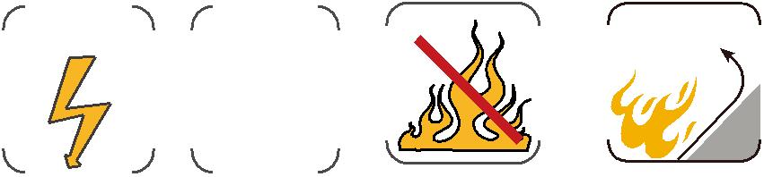

20 Caledonian

