 ADDISON

300/500V XLPE Insulated, PVC Sheathed Power Cables (Single Core)

FGD300 05RV-R (CU/XLPE/PVC 300/500V Class 2)

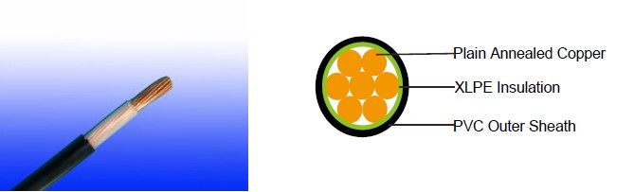

APPLICATION

The cables are mainly used in power stations, mass transit underground passenger systems, airports, petrochemical plants, hotels, hospitals, and high-rise buildings.

STANDARDS

Basic design adapted to IEC 60502-1

FIRE PERFORMANCE

Flame Retardance (Single Vertical EN 60332-1-2; IEC 60332-1-2; BS EN 60332-1-2; VDE _{Wire Test)**} 0482-332-1 ; NBN C 30-004 (cat. F1); NF C32-070-2.1(C2);
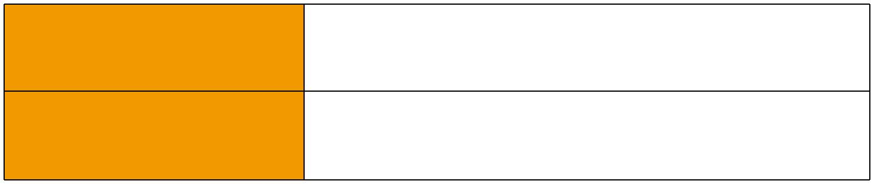
CEI 20-35/1-2; EN 50265-2-1*; DIN VDE 0482-265-2-1*

Reduced Fire Propagation | EN 60332-3-24 (cat. C); IEC 60332-3-24; BS EN 60332-3-24;
(Vertically-mounted bundled wires VDE 0482-332-3; NBN C 30-004 (cat. F2); NF C32-070-2.2(C1);
& cable test)** | CEI 20-22/3-4; EN 50266-2-4*; DIN VDE 0482-266-2-4

Note: Asterisk ** denotes that the standard compliance is optional, depending on the oxygen index of the PVC compound and the cable design.

VOLTAGE RATING

300/500V

CABLE CONSTRUCTION

Conductor: Plain annealed copper wire, stranded according to IEC(EN) 60228 class 2. Insulation: Extruded cross-linked XLPE compound.

Outer Sheath: Thermoplastic PVC compound. UV resistance, hydrocarbon resistance, oil resistance, anti rodent and anti termite properties can be offered as option. Compliance to fire performance standard (IEC 60332-1, IEC 60332-3, UL 1581, UL 1666 etc) depends on the oxygen index of the PVC compound and the overall cable design. LSPVC can also be provided upon request.

4 Caledonian


Caledonian

Flame Retardant Power & Control Cables

www.caledonian-cables.co.uk www.addison-cables.com

COLOUR CODE

Insulation Colour as per BS7671
 | With Earth Conductor | Without Earth Conductor
2Cores | - | Brown, Blue
3Cores | Yellow/Green, Brown, Blue | Brown, Gray, Black
4Cores | Yellow/Green, Brown, Gray, Black | Brown, Gray, Black, Blue
5Cores | Yellow/Green, Brown, Gray, Black, Blue | Brown, Gray, Black, Blue, Black
Above 5 Cores | Yellow/Green, Black Numbered | Black Numbered

Sheath Colour: Black (other colors upon request)

Physical AND THERMAL PROPERTIES

Temperature range during operation: Max.90°C for XLPE

250°C in short-circuit for 5secs max. Minimum bending radius: 6 x Overall Diameter (unarmoured cable)

10 x Overall Diameter (armoured cable)

CONSTRUCTION PARAMETERS

Conductor |  |  | FGD300 05RV-R
No. of Core X | No./Nominal | Nominal | Nominal | Approx.
No. of Core X | Diameter of | Insulation | Overall | Approx.
Cross Section | Diameter of | Insulation | Overall | Weight
Cross Section | Strands | Thickness | Diameter | Weight
Noxmm² | No./mm | mm | mm | kg/km
1x1.5 | 7/0.53 | 0.50 | 3.8 | 27
1x2.5 | 7/0.67 | 0.50 | 4.2 | 37
1x4.0 | 7/0.85 | 0.50 | 4.8 | 54

Electrical PROPERTIES

Conductor Operating Temperature : 90°C

Ambient Temperature : 30°C

Current-Carrying Capacities (Amp)


 | Reference
Conductor | Method 4
Conductor | (enclosed in
cross- | (enclosed in
cross- | conduit in
sectional | conduit in
sectional | thermally
area | thermally
area | insulating wall
 | etc)

Reference |  | Reference | Reference Method 12 (free
Reference |  | Reference |  | air)
Method 3 |  | Reference
Method 3 |  | Method 11 (on a
(enclosed in | Reference Method | Method 11 (on a
(enclosed in | Reference Method | perforated cable | Horizontal | Vertical
conduit on | 1 (clipped direct) | tray, horizontal or | flat | flat | Trefoil
a wall or in |  | vertical) | spaced | spaced
trunking etc) |  | vertical) | spaced | spaced

 ADDISON 5

ADDISON


 |  |  |  |  |  |  |  |  | 2 cables, | 2
 |  |  |  |  |  |  |  |  | 2 cables, | cables,
 | 2 |  | 2 |  | 2 cables, | 3 or 4 | 2 cables, | 3 or 4 | single- | single-
 | 2 |  | 2 |  | single- | cables, | single- | cables, | phase | single-
 | cables, | 3 or 4 | cables, | 3 or 4 |  |  |  |  |  | phase | 3 cables,
 |  |  |  |  | phase | 3-phase | phase | 3-phase | a.c. or | phase | 3 cables,
 | single- | cables, | single- | cables, |  |  |  |  |  | a.c. or | trefoil
 | phase | 3-phase | phase | 3-phase | a.c. or | a.c. flat | a.c. or | a.c. flat | d.c. | d.c. | 3-phase
 | a.c. or | a.c. | a.c. or | a.c. | d.c. flat | and | d.c. or | and | or 3 c | or 3 | a.c.
 | d.c. |  | d.c |  | and | touching | flat and | touching | ables | cables
 | d.c. |  | d.c |  | touching | or trefoil | touching | or trefoil | three | cables
 |  |  |  |  |  |  |  |  |  | three
 |  |  |  |  |  |  |  |  | phase | three
 |  |  |  |  |  |  |  |  | phase | phase
1 | 2 | 3 | 4 | 5 | 6 | 7 | 8 | 9 | 10 | 11 | 12
mm² | A | A | A | A | A | A | A | A | A | A | A
1.5 | 18 | 17 | 22 | 19 | 25 | 23 | - | - | - | - | -
2.5 | 24 | 23 | 30 | 26 | 34 | 31 | - | - | - | - | -
4 | 33 | 30 | 40 | 35 | 46 | 41 | - | - | - | - | -

Voltage Drop (Per Amp Per Meter)

Nominal |  |  |  |  |  |  |  | 2 cables, single-phase a.c. |  |  |  |  |  |  |  | 3 or 4 cables, 3-phase a.c.
 |  |  |  |  |  |  |  | Ref. Methods 3 |  |  |  |  | Ref. Methods 1 |  |  | Ref. Methods 3 |  |  | Ref. Methods 1 and
Cross |  |  | 2 cables |  |  |  |  |  |  |  |  |  |  |  |  |  |  | Ref. Methods 1, | Ref. Methods 1 and
Section |  |  |  | d.c. |  |  |  | and 4 (enclosed |  |  |  |  | and 11 (clipped |  |  | and 4 (enclosed |  |  | 11
Area |  |  |  |  |  |  |  | in conduit etc, |  |  |  |  | direct or on trays |  |  | in conduit etc, |  | 11 and 12 (in | (Flat and touching)
 |  |  |  |  |  |  |  | in or on a wall) |  |  |  |  | touching) |  |  | in or on a wall) |  | trefoil) | (Flat and touching)
1 |  |  | 2 |  |  |  |  | 3 |  |  |  |  | 4 |  |  | 5 |  | 6 | 7
 |  | mm² | mV/A/m |  |  |  |  | mV/A/m |  |  |  |  | mV/A/m |  |  | mV/A/m |  | mV/A/m | mV/A/m
1.5 |  |  | 31 |  |  |  |  | 31 |  |  |  |  | 27 |  |  | 27 |  | 27 | 27
2.5 |  |  | 19 |  |  |  |  | 19 |  |  |  |  | 16 |  |  | 16 |  | 16 | 16
4 |  |  | 33 |  |  |  |  | 12 |  |  |  |  | 10 |  |  | 10 |  | 10 | 10
 |  | 300/500V |  |  |  |  | IEC_{N}60502-1
 |  |  |  |  |  |  |  |  |  |  | Flame Retardancy**Reduced Fire Propagation**
Rated Voltage |  |  |  |  |  |  |  |  |  |  | NF C32-070-2.1(C2) |  |  |  | NF C32-070-2.2(C1)
 |  |  |  |  |  |  | Standard |  |  |  | _{IEC60332-1-2/EN50265-2-1} IEC60332-3-24/EN50266-2-4
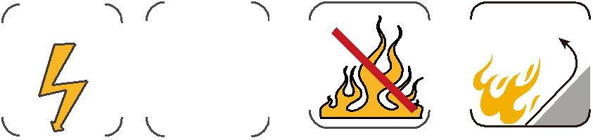

6 Caledonian

