
Caledonian

Flame Retardant Power & Control Cables

www.caledonian-cables.co.uk www.addison-cables.com

600/1000V XLPE Insulated, PVC Sheathed, Screened Power Cables (3C+3E)

FGD300 1RCV-R (CU/XLPE/CUTO/PVC 600/1000V Class 2)

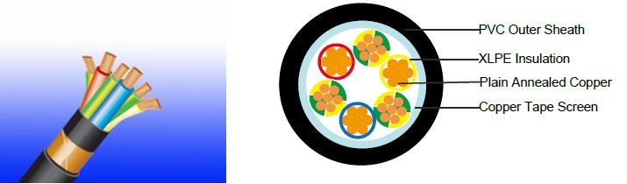

APPLICATION

The cables are designed specifically to suit the broad spectrum of requirements of Variable Speed

Drives and also include features for reducing the transmission of electromagnetic interference. These range of cables are able to reduce capacitance of power conductors and have an electrically balanced construction which includes split earths and a copper screen.

This range of screened cables drastically reduce interferences from electrical noise, especially in

Variable Speed Drive (VSD) applications and are manufactured with fixed conductors.

With shield conductivity of 1/10th of phase conductor conductivity, this range of VSD cables effectively restrain radiated and conducted radio-frequency emissions.

STANDARDS

Basic design adapted to IEC 60502-1

FIRE PERFORMANCE

Flame Retardance (Single Vertical EN 60332-1-2; IEC 60332-1-2; BS EN 60332-1-2; VDE _{Wire Test)**} 0482-332-1 ; NBN C 30-004 (cat. F1); NF C32-070-2.1(C2);
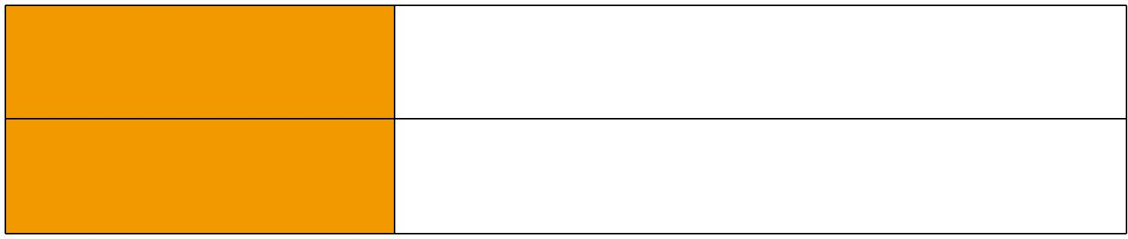
CEI 20-35/1-2; EN 50265-2-1*; DIN VDE 0482-265-2-1*

Reduced Fire Propagation | EN 60332-3-24 (cat. C); IEC 60332-3-24; BS EN 60332-3-24;
(Vertically-mounted bundled wires VDE 0482-332-3; NBN C 30-004 (cat. F2); NF C32-070-2.2(C1);
& cable test)** | CEI 20-22/3-4; EN 50266-2-4*; DIN VDE 0482-266-2-4

Note: Asterisk ** denotes that the standard compliance is optional, depending on the oxygen index of the PVC compound and the cable design.

VOLTAGE RATING

600/1000V

CABLE CONSTRUCTION

Conductor: Plain annealed copper wire, stranded according to IEC(EN) 60228 class 2.

 ADDISON 65

 ADDISON

Insulation: Extruded cross-linked XLPE compound. Screen: Copper Tape

Outer Sheath: Thermoplastic PVC compound. UV resistance, hydrocarbon resistance, oil resistance, anti rodent and anti termite properties can be offered as option. Compliance to fire performance standard (IEC 60332-1, IEC 60332-3, UL 1581, UL 1666 etc) depends on the oxygen index of the PVC compound and the overall cable design. LSPVC can also be provided upon request.

COLOUR CODE

Insulation Colour: Red, Yellow, Blue, Green/Yellow (x3) Outer sheath: Black or as order

Physical AND THERMAL PROPERTIES

Temperature range during operation: Max.90°C for XLPE

250°C in short-circuit for 5secs max.

Minimum bending radius: 10 x Overall Diameter

CONSTRUCTION PARAMETERS

Conductor |  |  |  | FGD300 1RCV-R
No. of Core X | No./Nominal | Combined | Nominal | Nominal | Nominal | Approx.
Cross Section | Diameter of | Earth Size | Insulation | Sheath | Overall | Weight
 | Strands |  | Thickness | Thickness | Diameter
mm² | No./mm | mm² | mm | mm | mm | kg/km
3x1.5 | 7/0.53 | 4.5(3x1.5) | 0.7 | 1.8 | 13.6 | 325
3x2.5 | 7/0.67 | 4.5(3x1.5) | 0.7 | 1.8 | 14.8 | 380
3x4 | 7/0.85 | 4.5(3x1.5) | 0.7 | 1.8 | 15.8 | 440
3x6 | 7/1.04 | 7.5(3x2.5) | 0.7 | 1.8 | 16.9 | 550
3x10 | 7/1.35 | 12(3x4) | 0.7 | 1.8 | 18.6 | 750
3x16 | 7/1.70 | 18(3x6) | 0.7 | 1.8 | 20.8 | 1000
3x25 | 7/2.14 | 30(3x10) | 0.9 | 1.8 | 24.0 | 1470
3x35 | 7/2.52 | 30(3x10) | 0.9 | 1.8 | 25.6 | 1890
3x50 | 19/1.78 | 30(3x10) | 1.0 | 1.9 | 31.1 | 2300
3x70 | 19/2.14 | 48(3x16) | 1.1 | 2.0 | 34.6 | 3200
3x95 | 19/2.52 | 48(3x16) | 1.1 | 2.2 | 39.3 | 4200
3x120 | 37/2.03 | 75(3x25) | 1.2 | 2.3 | 44.0 | 5400
3x150 | 37/2.25 | 75(3x25) | 1.4 | 2.5 | 49.0 | 6400
3x185 | 37/2.52 | 105(3x35) | 1.6 | 2.6 | 54.0 | 7900
3x240 | 61/2.25 | 150(3x50) | 1.7 | 2.8 | 61.0 | 10200
3x300 | 61/2.52 | 150(3x50) | 1.8 | 3.0 | 67.0 | 12300

66 Caledonian

Caledonian

Flame Retardant Power & Control Cables

www.caledonian-cables.co.uk www.addison-cables.com

Electrical PROPERTIES

Conductor Operating Temperature : 90°C

Ambient Temperature : 30°C

Current-Carrying Capacities (Amp)

 | Reference |  | Reference |  |  |  |  |  | Reference Method 12 (free
 | Method 4 |  |  |  |  |  | Reference |  |  | air)
Conductor |  |  | Method 3 |  |  |  |  |  |  | air)
Conductor | (enclosed |  |  |  |  |  | Method 11 (on a
cross- |  |  | (enclosed in |  | Reference Method
cross- | in conduit |  |  |  |  |  | perforated cable |  | Horizontal | Vertical
sectional | in thermally |  | conduit on |  | 1 (clipped direct) |  | tray, horizontal or |  | flat | flat | Trefoil
area | insulating wall |  | a wall or in |  |  |  | vertical) |  | spaced | spaced
 |  |  | trunking etc) |  |  |  |  |  | spaced | spaced
 | etc)
 |  |  |  |  |  |  |  |  | 2 cables, | 2
 |  |  |  |  |  |  |  |  | 2 cables, | cables,
 | 2 |  | 2 |  | 2 cables, | 3 or 4 | 2 cables, | 3 or 4 | single- | single-
 | 2 |  | 2 |  | single- | cables, | single- | cables, | phase | single-
 | cables, | 3 or 4 | cables, | 3 or 4 |  |  |  |  |  | phase | 3 cables,
 |  |  |  |  | phase | 3-phase | phase | 3-phase | a.c. or | phase | 3 cables,
 | single- | cables, | single- | cables, |  |  |  |  |  | a.c. or | trefoil
 | phase | 3-phase | phase | 3-phase | a.c. or | a.c. flat | a.c. or | a.c. flat | d.c. | d.c. | 3-phase
 | a.c. or | a.c. | a.c. or | a.c. | d.c. flat | and | d.c. or | and | or 3 c | or 3 | a.c.
 | d.c. |  | d.c |  | and | touching | flat and | touching | ables | cables
 | d.c. |  | d.c |  | touching | or trefoil | touching | or trefoil | three | cables
 |  |  |  |  |  |  |  |  |  | three
 |  |  |  |  |  |  |  |  | phase | three
 |  |  |  |  |  |  |  |  | phase | phase
1 | 2 | 3 | 4 | 5 | 6 | 7 | 8 | 9 | 10 | 11 | 12
mm² | A | A | A | A | A | A | A | A | A | A | A
1.5 | 18 | 17 | 22 | 19 | 25 | 23 | - | - | - | - | -
2.5 | 24 | 23 | 30 | 26 | 34 | 31 | - | - | - | - | -
4 | 33 | 30 | 40 | 35 | 46 | 41 | - | - | - | - | -
6 | 43 | 39 | 51 | 45 | 59 | 54 | - | - | - | - | -
10 | 58 | 53 | 71 | 63 | 81 | 74 | - | - | - | - | -
16 | 76 | 70 | 95 | 85 | 109 | 99 | - | - | - | - | -
25 | 100 | 91 | 126 | 111 | 143 | 130 | 158 | 140 | 183 | 163 | 138
35 | 125 | 111 | 156 | 138 | 176 | 161 | 195 | 176 | 226 | 203 | 171
50 | 149 | 135 | 189 | 168 | 228 | 209 | 293 | 215 | 274 | 246 | 209
70 | 189 | 170 | 240 | 214 | 293 | 268 | 308 | 279 | 351 | 318 | 270
95 | 228 | 205 | 290 | 259 | 355 | 326 | 375 | 341 | 426 | 389 | 330
120 | 263 | 235 | 336 | 299 | 413 | 379 | 436 | 398 | 495 | 453 | 385
150 | 300 | 270 | 375 | 328 | 476 | 436 | 505 | 461 | 570 | 524 | 445
185 | 341 | 306 | 426 | 370 | 545 | 500 | 579 | 530 | 651 | 600 | 511
240 | 400 | 358 | 500 | 433 | 644 | 590 | 686 | 630 | 769 | 711 | 606
300 | 459 | 410 | 573 | 493 | 743 | 681 | 794 | 730 | 886 | 824 | 701

 ADDISON 67

ADDISON

Voltage Drop (Per Amp Per Meter)

 |  |  | 2 cables, single-phase a.c. |  |  |  |  |  |  |  |  |  |  |  |  |  |  | 3 or 4 cables, 3-phase a.c.
Size of | 2 | Ref. Methods 3 |  |  |  |  |  |  | Ref. Methods 1 |  |  |  |  |  | Ref. Methods 3 |  |  |  | Ref. Methods 1, |  |  |  |  | Ref. Methods 1
Size of | cables | and 4 (enclosed |  |  |  |  |  |  | and 11 (clipped |  |  |  |  |  | and 4 (enclosed
conductor |  |  |  |  |  |  |  |  |  |  |  |  |  |  |  |  |  |  | 11 and 12 (in |  |  |  |  | and 11
 | d.c. | in conduit etc, in |  |  |  |  |  |  | direct or on trays |  |  |  |  |  | in conduit etc, in |  |  |  |  | trefoil) |  |  |  | (Flat and touching)
 |  |  | or on a wall) |  |  |  |  |  | touching) |  |  |  |  |  | or on a wall)
1 | 2 |  |  | 3 |  |  |  |  | 4 |  |  |  |  |  |  | 5 |  |  |  | 6 |  |  |  | 7
mm² | mV/A/m |  | mV/A/m |  |  |  |  |  | mV/A/m |  |  |  |  |  | mV/A/m |  |  |  |  | mV/A/m |  |  |  | mV/A/m
1.5 | 31 |  |  | 31 |  |  |  |  | 27 |  |  |  |  |  |  | 27 |  |  |  | 27 |  |  |  | 27
2.5 | 19 |  |  | 19 |  |  |  |  | 16 |  |  |  |  |  |  | 16 |  |  |  | 16 |  |  |  | 16
4 | 33 |  |  | 12 |  |  |  |  | 10 |  |  |  |  |  |  | 10 |  |  |  | 10 |  |  |  | 10
6 | 7.8 |  |  | 7.9 |  |  |  |  | 6.8 |  |  |  |  |  |  | 6.8 |  |  |  | 6.8 |  |  |  | 6.8
10 | 4.7 |  |  | 4.7 |  |  |  |  | 4.7 |  |  |  |  |  |  | 4 |  |  |  | 4 |  |  |  | 4
16 | 2.9 |  |  | 2.9 |  |  |  |  | 2.9 |  |  |  |  |  |  | 2.5 |  |  |  | 2.5 |  |  |  | 2.5
 |  |  | r | x |  | z |  |  | r | x |  |  | z |  | r | x |  | z | r |  | x |  | z | r | x | z
25 | 1.85 | 1.85 |  | 0.31 |  | 1.90 |  |  | 1.85 | 0.190 |  |  | 1.85 |  | 1.60 | 0.27 |  | 1.65 | 1.600 |  | 0.165 | 1.600 |  | 1.600 | 0.190 | 1.600
35 | 1.35 | 1.35 |  | 0.29 |  | 1.35 |  |  | 1.35 | 0.180 |  |  | 1.35 |  | 1.15 | 0.25 |  | 1.15 | 1.150 |  | 0.155 |  | 1.50 | 1.150 | 0.180 | 1.150
50 | 0.99 | 1.00 |  | 0.29 |  | 1.05 |  |  | 0.99 | 0.180 |  |  | 1.00 |  | 0.87 | 0.25 |  | 0.90 | 0.860 |  | 0.155 | 0.870 |  | 0.860 | 0.180 | 0.870
70 | 0.68 | 0.70 |  | 0.28 |  | 0.75 |  |  | 0.68 | 0.175 |  |  | 0.71 |  | 0.60 | 0.24 |  | 0.65 | 0.590 |  | 0.150 | 0.610 |  | 0.590 | 0.175 | 0.620
95 | 0.49 | 0.51 |  | 0.27 |  | 0.58 |  |  | 0.49 | 0.170 |  |  | 0.52 |  | 0.44 | 0.23 |  | 0.50 | 0.430 |  | 0.145 | 0.450 |  | 0.430 | 0.170 | 0.460
120 | 0.39 | 0.41 |  | 0.26 |  | 0.48 |  |  | 0.39 | 0.165 |  |  | 0.43 |  | 0.35 | 0.23 |  | 0.42 | 0.340 |  | 0.140 | 0.370 |  | 0.340 | 0.165 | 0.380
150 | 0.32 | 0.33 |  | 0.26 |  | 0.43 |  |  | 0.32 | 0.165 |  |  | 0.36 |  | 0.29 | 0.23 |  | 0.37 | 0.280 |  | 0.140 | 0.310 |  | 0.280 | 0.165 | 0.320
185 | 0.25 | 0.27 |  | 0.26 |  | 0.37 |  |  | 0.26 | 0.165 |  |  | 0.30 |  | 0.23 | 0.23 |  | 0.32 | 0.220 |  | 0.140 | 0.260 |  | 0.220 | 0.165 | 0.280
240 | 0.19 | 0.21 |  | 0.26 |  | 0.33 |  |  | 0.20 | 0.160 |  |  | 0.25 |  | 0.185 | 0.22 |  | 0.29 | 0.170 |  | 0.140 | 0.220 |  | 0.170 | 0.165 | 0.240
300 | 0.155 | 0.175 |  | 0.25 |  | 0.31 |  |  | 0.16 | 0.160 |  |  | 0.22 |  | 0.150 | 0.22 |  | 0.27 | 0.140 |  | 0.140 | 0.195 |  | 0.135 | 0.160 | 0.210
Note :
r = conductor resistance at operating temperature
x = reactance
z = impedance
600/1000V |  |  | IEC_{N}60502-1
 |  |  |  |  |  |  |  |  |  |  |  |  | Reduced Fire Propagation**
 |  |  |  |  |  | Flame Retardancy**
Rated Voltage |  |  | Standard |  |  | NF C32-070-2.1(C2) |  |  |  |  |  |  | NF C32-070-2.2(C1)
 |  |  |  |  |  | IEC60332-1-2/EN50265-2-1 |  |  |  |  |  |  | IEC60332-3-24/EN50266-2-4
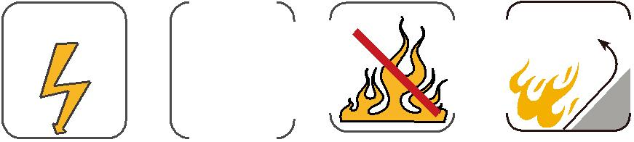

68 Caledonian

