 ADDISON

300/500V Braid-Screened Flexible Equipment Cables (Multipair)

LI-05SOZ1 FE180 (PH30) (CU/SR/OSCR/LSZH 300/500V Class 5)
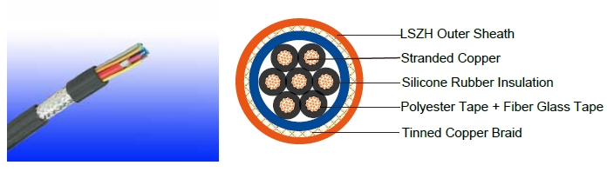

APPLICATION

The cables are designed for indoor instrumentation and control cabling, electrically noisy environments and fire alarm systems in office buildings.

STANDARDS

Basic design to VDE 0812/EN 50290-2-27

FIRE PERFORMANCE
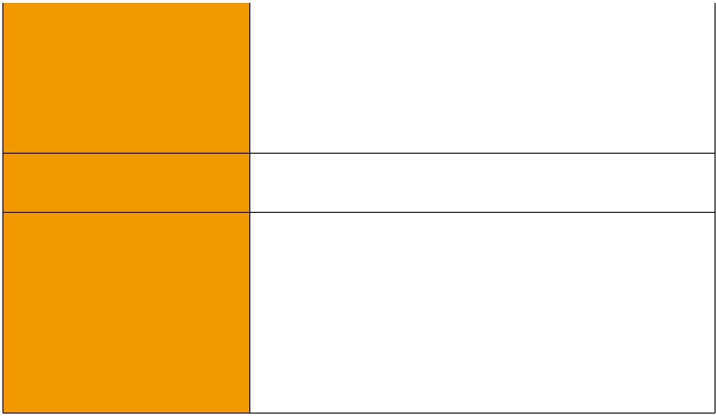
 | IEC 60331-21; BS 6387 CWZ; DIN VDE 0472-814(FE180);
Circuit Integrity | BS 8434-1 (30mins); BS 5839-1 Clause 26 2d; CEI 20-36/2-1;
 | SS229-1; NBN C 30-004 (cat. F3); NF C32-070-2.3(CR1)
Circuit Integrity with mechanical | EN 50200(PH30); CEI 20-36/4-0
shock | EN 50200(PH30); CEI 20-36/4-0
Circuit Integrity with mechanical | EN 50200 annex E
shock & water spray | EN 50200 annex E
System circuit integrity | DIN 4102-12, E30 depending on lay system
Flame Retardance (Single Vertical EN 60332-1-2; IEC 60332-1-2; BS EN 60332-1-2;

_{Wire Test)} VDE 0482-332-1 ; NBN C 30-004 (cat. F1); NF C32-070-2.1(C2); CEI 20-35/1-2; EN 50265-2-1*; DIN VDE 0482-265-2-1*

Reduced Fire Propagation | EN 60332-3-24 (cat. C); IEC 60332-3-24; BS EN 60332-3-24;
(Vertically-mounted bundled wires VDE 0482-332-3; NBN C 30-004 (cat. F2); NF C32-070-2.2(C1);
& cable test) | CEI 20-22/3-4; EN 50266-2-4*; DIN VDE 0482-266-2-4
Halogen Free | IEC 60754-1; EN 50267-2-1; DIN VDE 0482-267-2-1;
Halogen Free | CEI 20-37/2-1 ; BS 6425-1*
No Corrosive Gas Emission | IEC 60754-2; EN 50267-2-2; DIN VDE 0482-267-2-2;
No Corrosive Gas Emission | CEI 20-37/2-2 ; BS 6425-2*
Minimum Smoke Emission | IEC 61034-1&2; EN 61034 -1&2; DIN VDE 0482-1034-1&2;
Minimum Smoke Emission | CEI 20-37/3-1&2; EN 50268-1&2*; BS 7622-1&2*
No Toxic gases | NES 02-713; NF C 20-454

Note: Asterisk * denotes superseded standard.

90 Caledonian sales@caledonian-cables.net uk@caledonian-cables.net


 Caledonian
Fire Resistant Instrumention Cables

www.caledonian-tech.net www.caledonian-tech.com

CABLE CONSTRUCTION

Conductor: Plain annealed copper wire, stranded according to IEC(EN) 60228 class 2. Insulation: Fire resistant silicone rubber compound type EI2 as per BS 7655-1.1.

Cabling: The insulated cores are cabled in concentric layers with suitable non-hygroscopic fillers. Fire Barrier: Polyester tape + fiber glass tape

Overall screen: Aluminum/polyester tape with tinned copper braid (min. 85% Coverage)

Outer Sheath: Thermoplastic LSZH compound type LTS3 as per BS 7655-6.1 (Thermosetting LSZH compound type SW2-SW4 as per BS 7655-2.6 can be offered.) .

VOLTAGE RATING

300/500 V

COLOUR CODE

Insulation Colour: Per VDE 0812

Sheath Colour: Orange (other colours on request)

TYPE CODE

LI Equipment cable with fine stranded conductor

H Halogen free ceramic polymer compound

C Copper Wire Braid

FE180 Insulation integrity (950°C 180 minutes)

PH 90 Fire Test for 90 mins at 830°C

Physical AND THERMAL PROPERTIES

Temperature range during operation (fixed state):-30°C – +90°C

Temperature range during installation (mobile state): -20°C – +50°C

Minimum bending radius: 7.5 x Overall Diameter

Electrical PROPERTIES

Dielectric test: | 2000 V r.m.s. x 5’ (core/core)
Insulation Resistance | ≥300 MΩ x km (at 20°C);
Short circuit Temperature | 350°C

CONSTRUCTION PARAMETERS
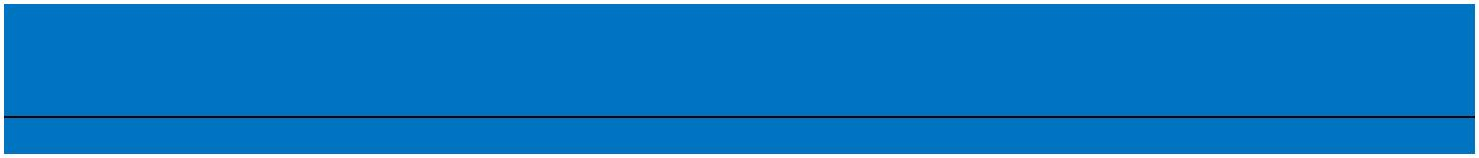
 | No. of Core X | Nominal | Nominal | Nominal | Approx.
Cable Code | No. of Core X | Insulation | Sheath | Overall | Approx.
Cable Code | Cross Section | Insulation | Sheath | Overall | Weight
 | Cross Section | Thickness | Thickness | Diameter | Weight
 | mm² | Thickness | Thickness | Diameter
 | mm² | mm | mm | mm | kg/km
 |  | 2 cores
LI-HCH FE180 (PH30) | 2x0.75 | 0.6 | 0.8 | 6.3 | 55
LI-HCH FE180 (PH30) | 2x1.0 | 0.6 | 0.9 | 6.9 | 62

 ADDISON 91

ADDISON

LI-HCH FE180 (PH30) | 2x1.5 | 0.7 | 0.9 | 7.3 | 79
 |  | 3 cores
LI-HCH FE180 (PH30) | 3x0.75 | 0.6 | 0.8 | 6.6 | 67
LI-HCH FE180 (PH30) | 3x1.0 | 0.6 | 0.9 | 7.2 | 77
LI-HCH FE180 (PH30) | 3x1.5 | 0.7 | 0.9 | 7.6 | 101
 |  | 4 cores
LI-HCH FE180 (PH30) | 4x0.75 | 0.6 | 0.9 | 7.2 | 85
LI-HCH FE180 (PH30) | 4x1.0 | 0.6 | 1.0 | 7.7 | 98
LI-HCH FE180 (PH30) | 4x1.5 | 0.7 | 1.0 | 8.2 | 112
 |  | 5 cores
LI-HCH FE180 (PH30) | 5x0.75 | 0.6 | 0.9 | 7.9 | 105
LI-HCH FE180 (PH30) | 5x1.0 | 0.6 | 1.0 | 7.9 | 117
LI-HCH FE180 (PH30) | 5x1.5 | 0.7 | 1.0 | 9.0 | 127
 |  | 6 cores
LI-HCH FE180 (PH30) | 6x0.75 | 0.6 | 0.9 | 8.6 | 121
LI-HCH FE180 (PH30) | 6x1.0 | 0.6 | 1.0 | 9.1 | 138
LI-HCH FE180 (PH30) | 6x1.5 | 0.7 | 1.0 | 10.0 | 161
 |  | 7 cores
LI-HCH FE180 (PH30) | 7x0.75 | 0.6 | 0.9 | 8.6 | 131
LI-HCH FE180 (PH30) | 7x1.0 | 0.6 | 1.0 | 9.1 | 152
LI-HCH FE180 (PH30) | 7x1.5 | 0.7 | 1.1 | 10.0 | 193

300/500V _{N}VDE0812
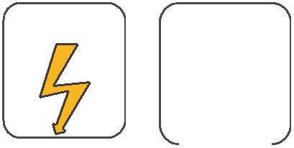
W

E
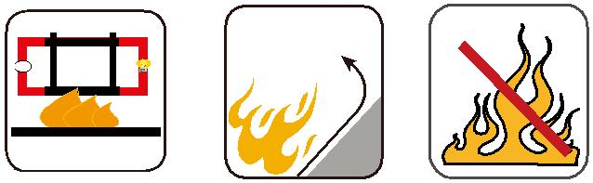

 |  |  |  | Circuit Integrity | Reduced Fire Propagation | Flame Retardancy
 |  |  |  | IEC 60331/BS 6387 | Reduced Fire Propagation | Flame Retardancy
 |  |  |  | IEC 60331/BS 6387 | NF C32-070-2.2(C1) | NF C32-070-2.1(C2)
Rated Voltage |  | Standard |  | EN 50200 | NF C32-070-2.2(C1) | NF C32-070-2.1(C2)
 |  | Standard |  | NF C32-070-2.3(CR1) | IEC60332-3-24/EN50266-2-4 IEC60332-1-2/EN50265-2-1
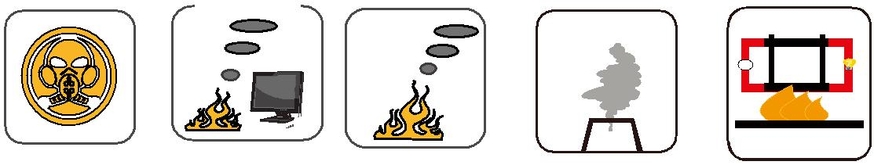

Zero

W

E

 | Low Corrosivity | Low Smoke Emission | Halogen Free
 | IEC60754-2 | Low Smoke Emission | Halogen Free
Low Toxicity | IEC60754-2 | IEC 61034-1&2 | Halogen Free
Low Toxicity | EN50267-2-2/3 | IEC 61034-1&2 | IEC60754-1 | Functional Integrity
NES 02-713/NF C 20-454 | NF C 32-074 | EN 50268-1&2/NF C32-073 | EN50267-2-1 | Functional Integrity
 |  |  | EN50267-2-1 | DIN 4102-12

92 Caledonian sales@caledonian-cables.net uk@caledonian-cables.net

