 ADDISON

300/500V Mica+XLPE Insulated Individual And Overall Screened Instrumentation

Cables

RE-2X(St)H PiMF...CI. FE 180 PH30 ( CU/MGT+XLPE/PSCR/OSCR/LSZH 300/500V Class 2 ) RE-2G(St)H PiMF...CI. FE 180 PH 30 ( CU/SR/PSCR/OSCR/LSZH 300/500V Class 2 )

RE-2X(St)HSWAH PiMF..CI. FE 180 PH 30 ( CU/MGT+XLPE/PSCR/OSCR/LSZH/SWA/LSZH

300/500V Class 2 )

RE-2G(St)HSWAH PiMF...CI. FE 180 PH 30 ( CU/SR/PSCR/OSCR/LSZH/SWA/LSZH 300/500V

Class 2 )
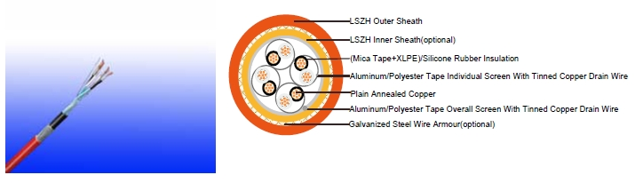

APPLICATION

The cables are designed, manufactured and tested as data transmission cables for emergency services. These are used for data and voice transmission when high frequency signal has to be assured also in the event of a fire.

STANDARDS

Basic design to BS 5308/BS 7629-1

FIRE PERFORMANCE
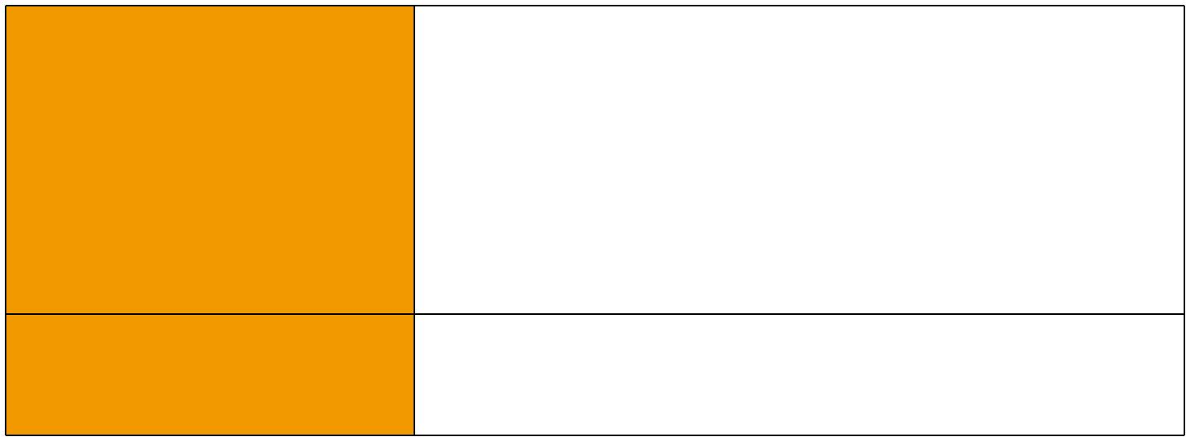
 | IEC 60331-21; BS 6387 CWZ; DIN VDE 0472-814(FE180);
Circuit Integrity | BS 8434-1 (30mins); BS 5839-1 Clause 26 2d; CEI 20-36/2-1;
 | SS229-1; NBN C 30-004 (cat. F3); NF C32-070-2.3(CR1)
Circuit Integrity with mechanical | EN 50200(PH30); CEI 20-36/4-0
shock | EN 50200(PH30); CEI 20-36/4-0
Circuit Integrity with mechanical | EN 50200 annex E
shock & water spray | EN 50200 annex E
System circuit integrity | DIN 4102-12, E30 depending on lay system
Flame Retardance (Single Vertical EN 60332-1-2; IEC 60332-1-2; BS EN 60332-1-2;

_{Wire Test)} VDE 0482-332-1 ; NBN C 30-004 (cat. F1); NF C32-070-2.1(C2); CEI 20-35/1-2; EN 50265-2-1*; DIN VDE 0482-265-2-1*

86 Caledonian sales@caledonian-cables.net uk@caledonian-cables.net


Caledonian

Fire Resistant Instrumention Cables

www.caledonian-tech.net www.caledonian-tech.com


Reduced Fire Propagation | EN 60332-3-24 (cat. C); IEC 60332-3-24; BS EN 60332-3-24;
(Vertically-mounted bundled wires | VDE 0482-332-3; NBN C 30-004 (cat. F2); NF C32-070-2.2(C1);
& cable test) | CEI 20-22/3-4; EN 50266-2-4*; DIN VDE 0482-266-2-4
Halogen Free | IEC 60754-1; EN 50267-2-1; DIN VDE 0482-267-2-1;
Halogen Free | CEI 20-37/2-1 ; BS 6425-1*
No Corrosive Gas Emission | IEC 60754-2; EN 50267-2-2; DIN VDE 0482-267-2-2;
No Corrosive Gas Emission | CEI 20-37/2-2 ; BS 6425-2*
Minimum Smoke Emission | IEC 61034-1&2; EN 61034 -1&2; DIN VDE 0482-1034-1&2;
Minimum Smoke Emission | CEI 20-37/3-1&2; EN 50268-1&2*; BS 7622-1&2*
No Toxic gases | NES 02-713; NF C 20-454

Note: Asterisk * denotes superseded standard.

CABLE CONSTRUCTION

Conductor: Plain annealed copper wire, stranded according to IEC(EN) 60228 class 2.

Insulation: Mica glass tape covered by extruded cross-linked XLPE compound or fire resistant silicone rubber compound type EI2 as per BS 7655-1.1.

Cabling Elements: Insulated cores are twisted to form pairs with varying lay length to minimize crosstalk. Two-pair cable had four cores laid in quad formation.

Cabling: Pairs are cabled together.In cables with 8 pairs or more, 4 pairs are assembled to form a bunch, the bunches are then cabled together.

Individual Screen: Aluminum/polyester tape with 0.5mm² screen (7/0.3mm) tinned copper drain wire.

Overall Screen: Aluminum/polyester tape with 0.5mm² screen (7/0.3mm) tinned copper drain wire. Inner Sheath(optional): Thermoplastic LSZH compound type LTS3 as per BS 7655-6.1 Armouring(optional): Galvanized steel wire armour

Outer Sheath: Thermoplastic LSZH compound type LTS3 as per BS 7655-6.1( Thermosetting LSZH compound type SW2-SW4 as per BS 7655-2.6 can be offered.)

VOLTAGE RATING

300/500 V

COLOUR CODE

Insulation Colour: White with black numberings.

Sheath Colour: Orange (other colours on request).

TYPE CODE

RE- | Instrumentation cable | H | Halogen free & zero halogen
2X | XLPE | 2G | Silicon Rubber
(St) | Static shield of aluminium tape | SWA | Steel Wire Armoured
FE180 | Insulation integrity (950°C 180 minutes) | CI | Circuit integrity
PH 90 Fire Test for 90 mins at 830°C

 ADDISON 87
ADDISON

Physical AND THERMAL PROPERTIES

Temperature range during operation (fixed state):-30°C – +70°C

Temperature range during installation (mobile state): -20°C – +50°C

Minimum bending radius: 6 x Overall Diameter (unarmoured cables with silicone rubber insulation) 8 x Overall Diameter (unarmoured cables with XLPE insulation)

10 x Overall Diameter (armoured cables)

Electrical PROPERTIES

Dielectric test: | 2000 V r.m.s. x 5’ (core/core)
Insulation Resistance | ≥1000 MΩ x km (at 20°C);
Short circuit Temperature | XLPE: 250°C
Short circuit Temperature | SR: 350°C

CONSTRUCTION PARAMETERS

RE-2X(St)H

PiMF...CI. FE 180

Conductor PH30 RE-2X(St)HSWAH PiMF..CI. FE 180 PH30

RE-2G(St)H RE-2G(St)HSWAH PiMF..CI. FE 180 PH30

PiMF...CI. FE 180

PH30

 | No. of Pairs | No./ | Nominal | Unarmoured |  |  | Armoured
 | No. of Pairs | Nominal | Nominal
 | No. of Pairs | Nominal | Nominal | Nominal |  | Diameter | Armour | Nominal
 | X Cross | Nominal | Insulation | Nominal | Approx. | Diameter | Armour | Nominal | Approx.
 | Section | Diameter | Thickness | Overall | Weight | Under | Wire | Overall | Weight
 | Section | of Strands | Thickness | Diameter | Weight | Armour | Diameter | Diameter | Weight
 | mm² | no./mm | mm | mm | kg/km | mm | mm | mm | kg/km
 |  |  |  |  | 2 Pairs
 | 2X2x1.0 | 7/0.43 | 0.6 | 15.2 | 166 | 15.2 | 0.90 | 20.0 | 555
 | 2X2x1.5 | 7/0.53 | 0.7 | 17.0 | 205 | 17.0 | 1.25 | 22.7 | 769
 | 2X2x2.5 | 7/0.67 | 0.8 | 19.2 | 350 | 19.2 | 1.25 | 24.9 | 938
 |  |  |  |  | 5 Pairs
 | 5X2x1.0 | 7/0.43 | 0.6 | 17.5 | 335 | 17.5 | 1.25 | 23.2 | 1000
 | 5X2x1.5 | 7/0.53 | 0.7 | 21.5 | 433 | 21.5 | 1.60 | 28.1 | 1352
 | 5X2x2.5 | 7/0.67 | 0.8 | 24.0 | 592 | 24.0 | 1.60 | 30.8 | 1665
 |  |  |  |  | 10 Pairs
 | 10X2x1.0 | 7/0.43 | 0.6 | 22.5 | 626 | 22.5 | 1.60 | 29.3 | 1800
 | 10X2x1.5 | 7/0.53 | 0.7 | 28.0 | 811 | 28.0 | 1.60 | 35.0 | 2165
 | 10X2x2.5 | 7/0.67 | 0.8 | 31.5 | 1132 | 31.5 | 2.00 | 39.5 | 3007
 |  |  |  |  | 20 Pairs
 | 20X2x1.0 | 7/0.43 | 0.6 | 30.5 | 1143 | 30.5 | 2.00 | 38.5 | 3019
 | 20X2x1.5 | 7/0.53 | 0.7 | 38.0 | 1509 | 38.0 | 2.00 | 46.2 | 3684
88 | Caledonian |  | sales@caledonian-cables.net |  | uk@caledonian-cables.net

Caledonian

Fire Resistant Instrumention Cables

www.caledonian-tech.net www.caledonian-tech.com

20X2x2.5 | 7/0.67 | 0.8 | 42.5 | 2112 | 42.5 | 2.50 | 51.9 | 5107

Note : Other conductor sizes & pair confi gurations are available upon request.

300/500V _{N}BS5308
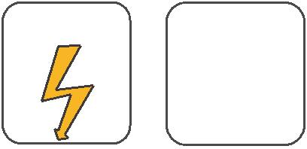
W

E
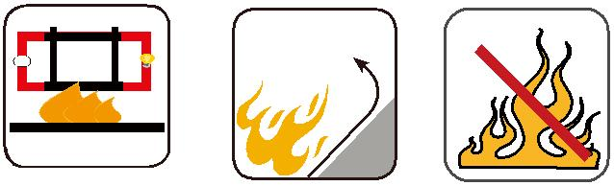

 |  | Circuit Integrity | Reduced Fire Propagation | Flame Retardancy
 |  | IEC 60331/BS 6387 | Reduced Fire Propagation
Rated Voltage | Standard | EN 50200 | NF C32-070-2.2(C1) | NF C32-070-2.1(C2)
Rated Voltage | Standard | NF C32-070-2.3(CR1) | IEC60332-3-24/EN50266-2-4 _{IEC60332-1-2/EN50265-2-1}
 |  |  | Zero | W | E
 | Low Corrosivity | Low Smoke Emission | Halogen Free
Low Toxicity | IEC60754-2 | IEC 61034-1&2 | IEC60754-1 | Functional Integrity
Low Toxicity | EN50267-2-2/3 | IEC 61034-1&2 | IEC60754-1
NES 02-713/NF C 20-454 | EN50267-2-2/3 | EN 50268-1&2/NF C32-073 | EN50267-2-1
NES 02-713/NF C 20-454 | NF C 32-074 | EN 50268-1&2/NF C32-073 | EN50267-2-1 |  | DIN 4102-12
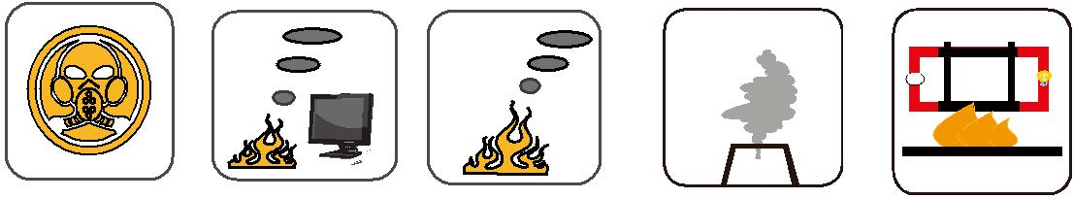

ADDISON 89

