
Caledonian

Fire Resistant Power & Control Cables

www.caledonian-tech.net www.caledonian-tech.com

300/500V SR Insulated & Overall Screened Control Cables (2-4 Cores & Multicores)

FFX200 05SOZ1-U (PH30/60) (CU/SR/OSCR/LSZH 300/500V Class 1)

FFX200 05SOZ1-R (PH30/60) (CU/SR/OSCR/LSZH 300/500V Class 2)

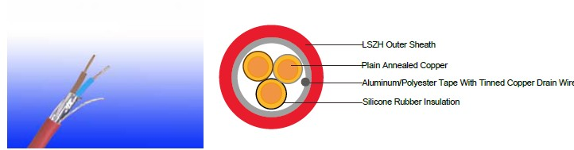

APPLICATION

The cables are primarily intended for use in the following applications:

BS 5266-1 for emergency lighting of premises
BS 5839-1 for fire detection and fire alarm systemsin and around building
BS 5839-8 for voice alarm systems

BS 5839-9 for emergency voice communication systems.

STANDARDS

Basic design to BS7629-1

FIRE PERFORMANCE
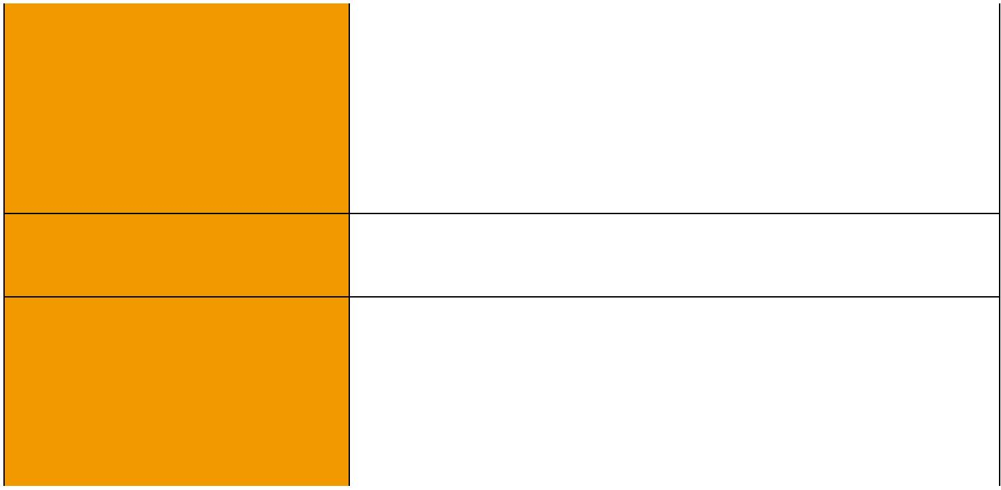
 | IEC 60331-21; BS 6387 CWZ; DIN VDE 0472-814(FE180);
Circuit Integrity | BS 8434-1 (30mins); BS 5839-1 Clause 26 2d; CEI 20-36/2-1;
 | SS229-1; NBN C 30-004 (cat. F3); NF C32-070-2.3(CR1)
Circuit Integrity with mechanical | EN 50200(PH30/60); CEI 20-36/4-0
shock | EN 50200(PH30/60); CEI 20-36/4-0
Circuit Integrity with mechanical | EN 50200 annex E
shock & water spray | EN 50200 annex E
System circuit integrity | DIN 4102-12, E30 depending on lay system
Flame Retardance (Single Vertical EN 60332-1-2; IEC 60332-1-2; BS EN 60332-1-2;

_{Wire Test)} VDE 0482-332-1 ; NBN C 30-004 (cat. F1); NF C32-070-2.1(C2); CEI 20-35/1-2; EN 50265-2-1*; DIN VDE 0482-265-2-1*

Reduced Fire Propagation | EN 60332-3-24 (cat. C); IEC 60332-3-24; BS EN 60332-3-24;
(Vertically-mounted bundled wires VDE 0482-332-3; NBN C 30-004 (cat. F2); NF C32-070-2.2(C1);
& cable test) | CEI 20-22/3-4; EN 50266-2-4*; DIN VDE 0482-266-2-4
Halogen Free | IEC 60754-1; EN 50267-2-1; DIN VDE 0482-267-2-1;
Halogen Free | CEI 20-37/2-1 ; BS 6425-1*
No Corrosive Gas Emission | IEC 60754-2; EN 50267-2-2; DIN VDE 0482-267-2-2;
No Corrosive Gas Emission | CEI 20-37/2-2 ; BS 6425-2*

 ADDISON 55

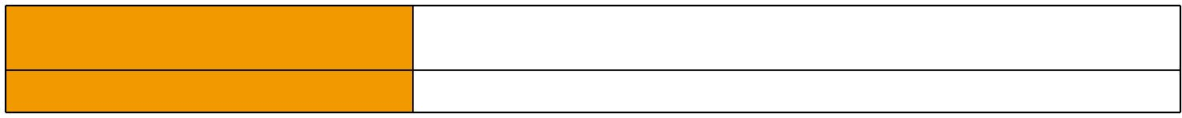
Insulation Colour:
2 cores
blue -brown
3 cores brown -black -grey
4 cores blue -brown -black -grey

Note: Asterisk * denotes superseded standard.
VOLTAGE RATING
300/500 V
CABLE CONSTRUCTION
Conductors: Plain annealed copper wire, solid according to IEC(EN) 60228 class 1, stranded according to IEC(EN) 60228 class 2.
Insulation: Fire resistant silicone rubber compound type EI2 as per BS 7655-1.1.
Cabling: The cores are cabled together in concentric layers with suitable non-hygroscopic fillers.
Overall screen: Aluminum/polyester tape with tinned copper drain wire.
Circuit Protective Conductor or Drain Wire: Uninsulated tinned copper conductor of the same section and class as the insulated conductors in the 2-, 3-and 4-core cables. Drain wire of 0.5mm² tinned copper conductor is provided in cables of more than 4 conductors.
Outer Sheath: Thermoplastic LSZH compound type LTS3 as per BS 7655-6.1 (Thermosetting LSZH compound type SW2-SW4 as per BS 7655-2.6 can be offered.)
COLOUR CODE

ADDISON
Minimum Smoke Emission
No Toxic gases

IEC 61034-1&2; EN 61034 -1&2; DIN VDE 0482-1034-1&2;

CEI 20-37/3-1&2; EN 50268-1&2*; BS 7622-1&2*

NES 02-713; NF C 20-454

(Colour Code Up To 4 Cores In Accordance To Hd 308)

7 cores centre: brown 1st layer: brown -black -4 cores white

12 cores centre: brown -black -white 1st layer: brown -black -7 cores white

19 cores centre: brown

1st layer: brown -black -4 cores white

2nd layer: brown -black -10 cores white

(on request the cores can be one colour only, identified by printed numbers)

Sheath Colour: Orange (other colors upon request)

Physical AND THERMAL PROPERTIES

Temperature range during operation (fixed state):-30°C – +90°C

Temperature range during installation (mobile state): -20°C – +50°C

Minimum bending radius: 6 x Overall Diameter

Electrical PROPERTIES

Dielectric test: | 2000 V r.m.s. x 5’ (core/core)
Insulation resistance | ≥300 MΩ x km (at 20°C)
Short circuit temperature | 350°C

56 Caledonian sales@caledonian-cables.net uk@caledonian-cables.net

Caledonian

Fire Resistant Power & Control Cables

www.caledonian-tech.net www.caledonian-tech.com

CONSTRUCTION PARAMETERS

 | No. of Core X | Nominal | Nominal | Nominal | Approx.
Cable Code | No. of Core X | Insulation | Sheath | Overall | Approx.
Cable Code | Cross Section | Insulation | Sheath | Overall | Weight
 | Cross Section | Thickness | Thickness | Diameter | Weight
 | mm² | mm | mm | mm | kg/km
 | 2 core
FFX200 05SOZ1-U (PH30/60) | 2x1.0 | 0.6 | 0.9 | 7.1 | 80
FFX200 05SOZ1-U (PH30/60) | 2x1.5 | 0.7 | 0.9 | 8.0 | 95
FFX200 05SOZ1-U (PH30/60) | 2x2.5 | 0.8 | 1.0 | 9.4 | 135
FFX200 05SOZ1-R (PH30/60) | 2x1.5 | 0.7 | 0.9 | 8.4 | 106
FFX200 05SOZ1-R (PH30/60) | 2x2.5 | 0.8 | 1.0 | 9.9 | 145
FFX200 05SOZ1-R (PH30/60) | 2x4.0 | 0.8 | 1.1 | 11.5 | 210
 | 3 core
FFX200 05SOZ1-U (PH30/60) | 3x1.0 | 0.6 | 0.9 | 8.0 | 95
FFX200 05SOZ1-U (PH30/60) | 3x1.5 | 0.7 | 0.9 | 8.5 | 115
FFX200 05SOZ1-U (PH30/60) | 3x2.5 | 0.8 | 1.0 | 10.0 | 170
FFX200 05SOZ1-R (PH30/60) | 3x1.5 | 0.7 | 0.9 | 8.9 | 134
FFX200 05SOZ1-R (PH30/60) | 3x2.5 | 0.8 | 1.0 | 10.3 | 180
FFX200 05SOZ1-R (PH30/60) | 3x4.0 | 0.8 | 1.1 | 12.2 | 260
 | 4 core
FFX200 05SOZ1-U (PH30/60) | 4x1.0 | 0.6 | 1.0 | 8.3 | 115
FFX200 05SOZ1-U (PH30/60) | 4x1.5 | 0.7 | 1.0 | 9.4 | 150
FFX200 05SOZ1-U (PH30/60) | 4x2.5 | 0.8 | 1.1 | 11.0 | 210
FFX200 05SOZ1-R (PH30/60) | 4x1.5 | 0.7 | 1.0 | 9.8 | 166
FFX200 05SOZ1-R (PH30/60) | 4x2.5 | 0.8 | 1.1 | 11.8 | 250
FFX200 05SOZ1-R (PH30/60) | 4x4.0 | 0.8 | 1.2 | 13.5 | 330
 | 7 Core
FFX200 05SOZ1-U (PH30/60) | 7x1.0 | 0.6 | 1.0 | 10.0 | 165
FFX200 05SOZ1-U (PH30/60) | 7x1.5 | 0.7 | 1.1 | 11.3 | 225
 | 12 core
FFX200 05SOZ1-U (PH30/60) | 12x1.0 | 0.6 | 1.1 | 12.5 | 255
FFX200 05SOZ1-U (PH30/60) | 12x1.5 | 0.7 | 1.2 | 14.5 | 350
 | 19 core
FFX200 05SOZ1-U (PH30/60) | 19x1.0 | 0.6 | 1.2 | 15.0 | 380
FFX200 05SOZ1-U (PH30/60) | 19x1.5 | 0.7 | 1.3 | 17.0 | 520


ADDISON 57

 ADDISON

ELECTRICAL PROPERTIES

Conductor Operating Temperature : 90°C

Ambient Temperature : 30°C

Current-Carrying Capacities (Amp)

 | Reference | Reference Method 3 |  |  |  | Reference Method 11
 | Method 4
 | (enclosed in |  |  | Reference Method 1
 | an conduit |  |  | (clipped direct)
 | insulated | (enclosed in conduit on |  |  |  | (on a perforated cable
Nominal | wall etc) | a wall or ceiling, or in |  |  |  | tray), or Reference
Nominal |  | trunking) |  |  |  | Method 13 (free air)
Cross
Cross |  |  |  |  |  | one 2-core | one
Section |  |  |  |  |  | one 2-core | 3-core
Area |  |  |  |  | one 3-core | cable single | cable or
 | one 3-core | one 2-core | one 3-core | one 2-core | cable or | cable single | cable or
 | cable or one | cable single | cable or one | cable single | one 4-core | phase | one
 | 4-core cable | phase a.c. or | 4-core cable | phase a.c. or | cable
 |  |  |  |  |  |  | 4-core
 | 3-phase a.c. | d.c. | 3-phase a.c. | d.c. | 3-phase | a.c. or | 4-core
 |  |  |  |  |  |  | cable
 |  |  |  |  | a.c. |  | cable
 |  |  |  |  | a.c. | d.c. | 3-phase
 |  |  |  |  |  | d.c. | a.c.
1 | 2 | 3 | 4 | 5 | 6 | 7 | 8
mm² | A | A | A | A | A | A | A
1.5 | 16.5 | 22 | 19.5 | 24 | 22 | 26 | 23
2.5 | 22 | 30 | 26 | 33 | 30 | 36 | 32
4 | 30 | 40 | 35 | 45 | 40 | 49 | 42
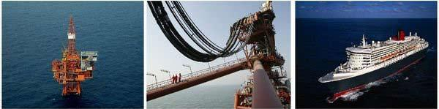

58 Caledonian sales@caledonian-cables.net uk@caledonian-cables.net

Caledonian

Fire Resistant Power & Control Cables

www.caledonian-tech.net www.caledonian-tech.com

Voltage Drop (Per Amp Per Meter)

Nominal Cross | 2-core cable d.c. | 2-core cable single- | 3-core or 4-core cable
Section Area | 2-core cable d.c. | phase a.c | 3-phase a.c.
1 | 2 | 3 | 4
mm² | mV/A/m | mV/A/m | mV/A/m
1.5 | 31 | 31 | 27
2.5 | 19 | 19 | 16
4 | 12 | 12 | 10

300/500V _{N}^{BS7629-1}
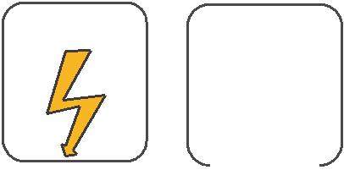
W

E
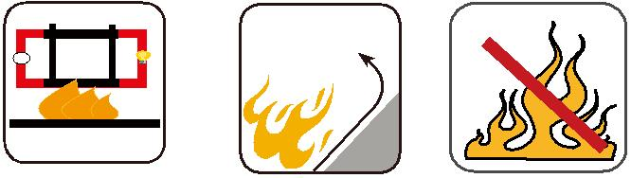

 |  |  | Circuit Integrity | Reduced Fire Propagation |  |  | Flame Retardancy
 |  |  | IEC 60331/BS 6387 |  |  |  | Flame Retardancy
 |  |  | IEC 60331/BS 6387 | NF C32-070-2.2(C1) |  |  | NF C32-070-2.1(C2)
Rated Voltage |  |  | EN 50200 |  |  |  | NF C32-070-2.1(C2)
Rated Voltage | Standard |  | NF C32-070-2.3(CR1) | IEC60332-3-24/EN50266-2-4 IEC60332-1-2/EN50265-2-1
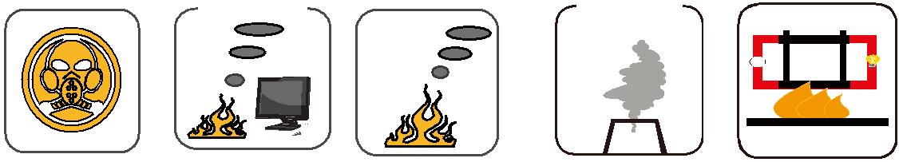

Zero

W

E

 | Low Corrosivity | Low Smoke Emission | Halogen Free
 | IEC60754-2 | Low Smoke Emission | Halogen Free
Low Toxicity | IEC60754-2 | IEC 61034-1&2 | IEC60754-1 | Functional Integrity
Low Toxicity | EN50267-2-2/3 | IEC 61034-1&2 | IEC60754-1 | Functional Integrity
NES 02-713/NF C 20-454 | NF C 32-074 | EN 50268-1&2/NF C32-073 | EN50267-2-1 | DIN 4102-12

 ADDISON 59

