
Caledonian

Fire Resistant Power & Control Cables

www.caledonian-tech.net www.caledonian-tech.com

300/500V SR Insulated Control Cables (2-4 Cores)

FFX200 05SZ1-U (PH60) (CU/SR/LSZH 300/500V Class 1)
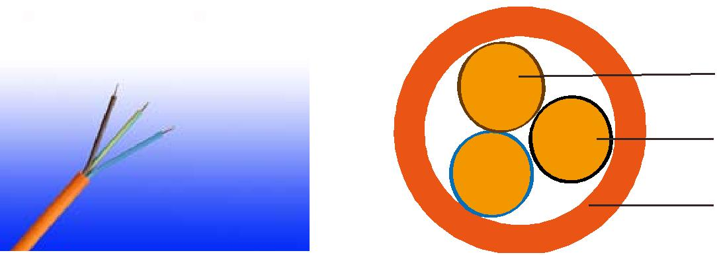

Plain Annealed Copper

Silicone Rubber Insulation

LSZH Outer Sheath

APPLICATION

The cables are designed, for use as control cable for emergency services and fire circuit control.

STANDARDS

Basic design adapted from BS 7629-1

FIRE PERFORMANCE

 | IEC 60331-21; BS 6387 CWZ; DIN VDE 0472-814(FE180);
Circuit Integrity | BS 8434-1 (30mins); BS 5839-1 Clause 26 2d; CEI 20-36/2-1;
 | SS229-1; NBN C 30-004 (cat. F3); NF C32-070-2.3(CR1)
Circuit Integrity with mechanical | EN 50200(PH60); CEI 20-36/4-0
shock
Circuit Integrity with mechanical | EN 50200 annex E
shock & water spray
System circuit integrity | DIN 4102-12, E30 depending on lay system
Flame Retardance (Single | EN 60332-1-2; IEC 60332-1-2; BS EN 60332-1-2;
Flame Retardance (Single | VDE 0482-332-1 ; NBN C 30-004 (cat. F1); NF C32-070-2.1(C2);
Vertical Wire Test) | VDE 0482-332-1 ; NBN C 30-004 (cat. F1); NF C32-070-2.1(C2);
Vertical Wire Test) | CEI 20-35/1-2; EN 50265-2-1*; DIN VDE 0482-265-2-1*
Reduced Fire Propagation | EN 60332-3-24 (cat. C); IEC 60332-3-24; BS EN 60332-3-24;
(Vertically-mounted bundled | VDE 0482-332-3; NBN C 30-004 (cat. F2); NF C32-070-2.2(C1);
wires & cable test) | CEI 20-22/3-4; EN 50266-2-4*; DIN VDE 0482-266-2-4
Halogen Free | IEC 60754-1; EN 50267-2-1; DIN VDE 0482-267-2-1;
Halogen Free | CEI 20-37/2-1 ; BS 6425-1*
No Corrosive Gas Emission | IEC 60754-2; EN 50267-2-2; DIN VDE 0482-267-2-2;
No Corrosive Gas Emission | CEI 20-37/2-2 ; BS 6425-2*
Minimum Smoke Emission | IEC 61034-1&2; EN 61034 -1&2; DIN VDE 0482-1034-1&2;
Minimum Smoke Emission | CEI 20-37/3-1&2; EN 50268-1&2*; BS 7622-1&2*
No Toxic gases | NES 02-713; NF C 20-454

Note: Asterisk * denotes superseded standard.

 ADDISON 51

 ADDISON

VOLTAGE RATING

300/500 V

CABLE CONSTRUCTION

Conductors: Plain annealed copper wire, solid according to IEC(EN) 60228 class 1.

Insulation: Fire resistant silicone rubber compound type EI2 as per BS 7655-1.1.

Cabling: The cores are cabled together in concentric layers with suitable non-hygroscopic fillers.

Outer Sheath: Thermoplastic LSZH compound type LTS3 as per BS 7655-6.1 (Thermosetting LSZH compound type SW2-SW4 as per BS 7655-2.6 can be offered.)

COLOUR CODE

Insulation Colour

Without earth conductor 2 cores black - blue

3 cores black - blue - brown

4 cores black - blue - brown - black With earth conductor

3 cores black - blue - yellow/green

4 cores black - blue - brown - yellow/green

Sheath Colour: Orange (other colors upon request)

Physical AND THERMAL PROPERTIES

Temperature range during operation (fixed state):-30°C – +90°C

Temperature range during installation (mobile state): -20°C – +50°C

Minimum bending radius: 6 x Overall Diameter

Electrical PROPERTIES

Dielectric test: | 2000 V r.m.s. x 5’ (core/core)
Insulation resistance | ≥300 MΩ x km (at 20°C)
Short circuit temperature | 350°C

52 Caledonian sales@caledonian-cables.net uk@caledonian-cables.net

Caledonian

Fire Resistant Power & Control Cables

www.caledonian-tech.net www.caledonian-tech.com

CONSTRUCTION PARAMETERS

 | No. of Core | Nominal | Nominal | Nominal | Approx.
Cable Code | X Cross | Insulation | Sheath | Overall | Approx.
 |  |  |  |  | Weight
 | Section | Thickness | Thickness | Diameter | Weight
 | mm² | mm | mm | mm | kg/km
 |  | 2 core
FFX200 05SZ1-U (PH60) | 2x1.5 | 0.7 | 0.9 | 7.4 | 70
FFX200 05SZ1-U (PH60) | 2x2.5 | 0.8 | 1.0 | 8.8 | 105
 |  | 3 core
FFX200 05SZ1-U (PH60) | 3x1.5 | 0.7 | 0.9 | 7.9 | 93
FFX200 05SZ1-U (PH60) | 3x2.5 | 0.8 | 1.0 | 9.4 | 141
 |  | 4 core
FFX200 05SZ1-U (PH60) | 4x1.5 | 0.7 | 1.0 | 8.8 | 122
FFX200 05SZ1-U (PH60) | 4x2.5 | 0.8 | 1.1 | 10.4 | 183

ELECTRICAL PROPERTIES

Conductor Operating Temperature : 90°C

Ambient Temperature : 30°C

Current-Carrying Capacities (Amp)

 | Reference
 | Method 4 | Reference Method 3 |  |  |  | Reference Method 11
 | (enclosed in | (enclosed in conduit on |  | Reference Method 1 |  | (on a perforated cable
 | an conduit | a wall or ceiling, or in |  | (clipped direct) |  | tray), or Reference Method
Conductor | insulated wall | trunking) |  |  |  | 13 (free air)
cross- | etc)
sectional |  |  |  |  |  | one 2-core
area | one 3-core | one 2-core | one 3-core | one 2-core | one 3-core | one 2-core | one 3-core
 |  |  |  |  |  | cable | one 3-core
 | cable or one | cable | cable or one | cable | cable or one | cable | cable or one
 |  |  |  |  |  | singlephase | cable or one
 | 4-core cable | singlephase | 4-core cable | singlephase | 4-core cable | singlephase | 4-core cable
 | 3-phase a.c. | a.c. or d.c. | 3-phase a.c. | a.c. or d.c. | 3-phase a.c. | a.c. or | 3-phase a.c.
 |  |  |  |  |  | d.c. | 3-phase a.c.
1 | 2 | 3 | 4 | 5 | 6 | 7 | 8
mm² | A | A | A | A | A | A | A
1.5 | 16.5 | 22 | 19.5 | 24 | 22 | 26 | 23
2.5 | 22 | 30 | 26 | 33 | 30 | 36 | 32

ADDISON 53

ADDISON

Voltage Drop (Per Amp Per Meter)

Nominal Cross | 2-core cable d.c. | 2 cables, single-phase | 3 or 4 cables, 3-phase
Section Area | 2-core cable d.c. | a.c. | a.c.
1
1 | 2 | 3 | 4
mm² | mV/A/m | mV/A/m | mV/A/m
1.5 | 31 | 31 | 27
2.5 | 19 | 19 | 16

300/500V _{N}^{BS7629-1}
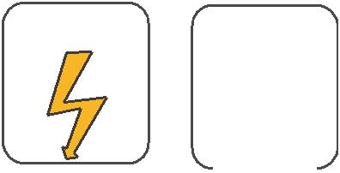
W

E
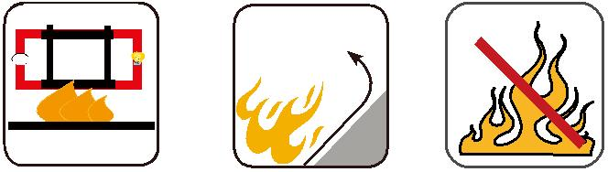

 |  |  |  |  | Circuit Integrity | Reduced Fire Propagation |  |  | Flame Retardancy
 |  |  |  |  | IEC 60331/BS 6387 | NF C32-070-2.2(C1) |  |  | NF C32-070-2.1(C2)
Rated Voltage |  |  | Standard |  | EN 50200 | IEC60332-3-24/EN50266-2-4 |  |  | IEC60332-1-2/EN50265-2-1
 |  |  | Standard |  | NF C32-070-2.3(CR1) |  |  |  | IEC60332-1-2/EN50265-2-1
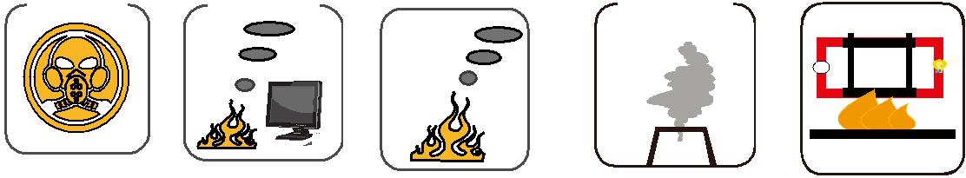

Zero

W

E

 | Low Corrosivity | Low Smoke Emission | Halogen Free
Low Toxicity | IEC60754-2 | Low Smoke Emission | Halogen Free
Low Toxicity | IEC60754-2 | IEC 61034-1&2 | IEC60754-1
NES 02-713/NF C 20-454 | EN50267-2-2/3 | IEC 61034-1&2 | IEC60754-1 | Functional Integrity
 | NF C 32-074 | EN 50268-1&2/NF C32-073 | EN50267-2-1 | DIN 4102-12

54 Caledonian sales@caledonian-cables.net uk@caledonian-cables.net

