
Caledonian

Fire Resistant Power & Control Cables

www.caledonian-tech.net www.caledonian-tech.com

300/500V Mica+XLPE Insulated, LSZH Sheathed Power Cables (Single Core)

FFX300 05mRZ1-R (CU/MGT+XLPE/LSZH 300/500V Class 2)
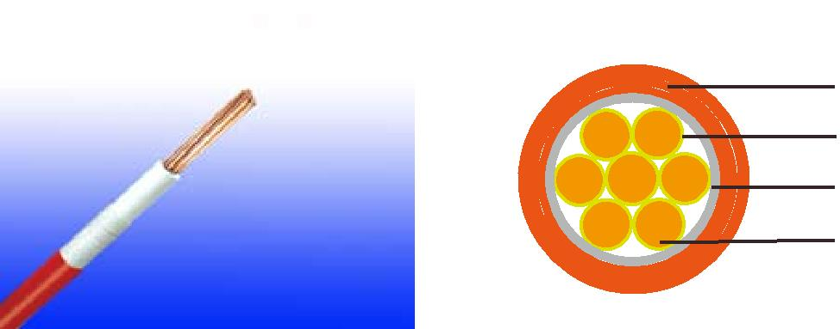

LSZH Outer Sheath

Mica Glass Tape

XLPE Insulation

Plain Annealed Copper

APPLICATION

The cables are designed for areas where the integrity of the electrical circuit is critical in maintaining power supply. Applications can be found in emergency lightings, control and power circuits, power stations, fire alarm systems, underground tunnels, lifts, escalators, and high-rise buildings.

STANDARDS

Basic design to IEC 60502-1

FIRE PERFORMANCE
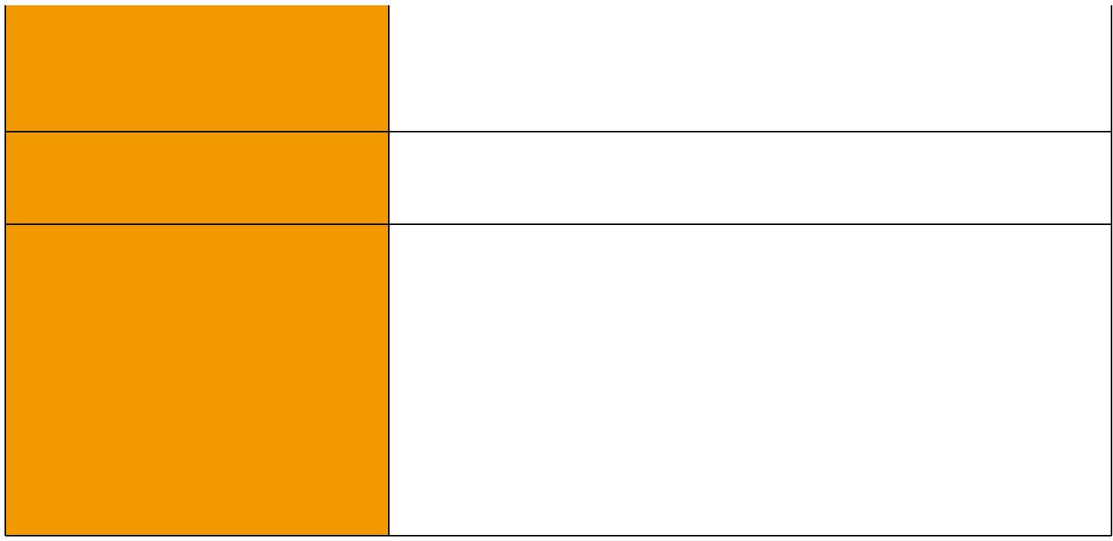
 | IEC 60331-21; BS 6387 CWZ; DIN VDE 0472-814(FE180);
Circuit Integrity | CEI 20-36/2-1; SS229-1; NBN C 30-004 (cat. F3);
 | NF C32-070-2.3(CR1)
System circuit integrity | DIN 4102-12, E30 depending on lay system
Flame Retardance (Single Vertical EN 60332-1-2; IEC 60332-1-2; BS EN 60332-1-2;
_{Wire Test)} VDE 0482-332-1 ; NBN C 30-004 (cat. F1); NF C32-070-2.1(C2); CEI 20-35/1-2; EN 50265-2-1*; DIN VDE 0482-265-2-1*

Reduced Fire Propagation | EN 60332-3-24 (cat. C); IEC 60332-3-24; BS EN 60332-3-24;
(Vertically-mounted bundled wires VDE 0482-332-3; NBN C 30-004 (cat. F2); NF C32-070-2.2(C1);
& cable test) | CEI 20-22/3-4; EN 50266-2-4*; DIN VDE 0482-266-2-4
Halogen Free | IEC 60754-1; EN 50267-2-1; DIN VDE 0482-267-2-1;
Halogen Free | CEI 20-37/2-1 ; BS 6425-1*
No Corrosive Gas Emission | IEC 60754-2; EN 50267-2-2; DIN VDE 0482-267-2-2;
No Corrosive Gas Emission | CEI 20-37/2-2 ; BS 6425-2*
Minimum Smoke Emission | IEC 61034-1&2; EN 61034 -1&2; DIN VDE 0482-1034-1&2;
Minimum Smoke Emission | CEI 20-37/3-1&2; EN 50268-1&2*; BS 7622-1&2*
No Toxic gases | NES 02-713; NF C 20-454

Note: Asterisk * denotes superseded standard.

 ADDISON 31

 ADDISON

VOLTAGE RATING

300/500 V

CABLE CONSTRUCTION

Conductor: Plain annealed copper wire, stranded according to IEC(EN) 60228 class 2.

Insulation: Mica glass tape covered by extruded cross-linked XLPE compound

Earth Conductor(optional): Uninsulated solid or stranded tinned copper conductor.

Outer Sheath: Thermoplastic LSZH compound type LTS3 as per BS 7655-6.1 (Thermosetting LSZH compound type SW2-SW4 as per BS 7655-2.6 can be offered.)

Physical AND THERMAL PROPERTIES

Temperature range during operation (fixed state):-30°C – +90°C

Temperature range during installation (mobile state): -20°C – +50°C Minimum bending radius: 8 x Overall Diameter

Electrical PROPERTIES

Dielectric test: |  | 2000 V r.m.s. x 5’ (core/core)
Insulation resistance |  | 1000 MΩ x km (at 20°C)
Short circuit temperature |  | 250°C
CONSTRUCTION PARAMETERS
Conductor |  |  |  | FFX300 05mRZ1-R
 | No./Nominal |  | Nominal | Nominal | Without Earth Conductor
Nominal Cross |  |  | Nominal | Nominal
 |  |  |  |  | Nominal
Nominal Cross | Diameter of |  | Insulation | Sheath | Nominal | Approx.
Section Area |  |  | Insulation | Sheath | Overall | Approx.
Section Area | Strands |  | Thickness | Thickness | Overall | Weight
 |  |  | Thickness | Thickness | Diameter | Weight
mm² | No./mm |  | mm | mm | mm | kg/km
1.5 | 7/0.53 |  | 0.5 | 0.5 | 4.4 | 29
2.5 | 7/0.67 |  | 0.5 | 0.5 | 4.9 | 40
4 | 7/0.85 |  | 0.5 | 0.5 | 5.5 | 55

ElectricAl PROPERTIES

Conductor Operating Temperature : 90°C

Ambient Temperature : 30°C

32 Caledonian sales@caledonian-cables.net uk@caledonian-cables.net

Flame Retardancy
NF C32-070-2.1(C2)

