 ADDISON

600/1000V Mica+XLPE Insulated, LSZH Sheathed Power Cables (Single-Core)

FFX300 1mRZ1-R (CU/MGT+XLPE/LSZH 600/1000V Class 2)

FFX300 1mRMZ1-R (CU/MGT+XLPE/LSZH/AWA/LSZH 600/1000V Class 2)
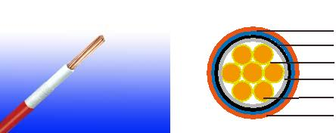

Aluminum wire armour(optional)

LSZH Inner Sheath(optional)

Mica Glass Tape

XLPE Insulation

Plain Annealed Copper

LSZH Outer Sheath

APPLICATION

This cable is designed for areas where the integrity of the electrical circuit is critical in maintaining power supply. Applications can be found in emergency lightings, control and power circuits, power stations, fire alarm systems, underground tunnels, communications systems, sewage treatment plants, lifts, escalators, and high-rise buildings.

STANDARDS

Basic design to IEC 60502-1 / BS 6724

FIRE PERFORMANCE

 | IEC 60331-21; BS 6387 CWZ; DIN VDE 0472-814(FE180);
Circuit Integrity | CEI 20-36/2-1; SS229-1; NBN C 30-004 (cat. F3); NF C32-070-
 | 2.3(CR1)
System circuit integrity | DIN 4102-12, E30 depending on lay system
 | EN 60332-1-2; IEC 60332-1-2; BS EN 60332-1-2;
Flame Retardance (Single Vertical | VDE 0482-332-1 ; NBN C 30-004 (cat. F1);
Wire Test) | NF C32-070-2.1(C2); CEI 20-35/1-2; EN 50265-2-1*;
 | DIN VDE 0482-265-2-1*
Reduced Fire Propagation | EN 60332-3-24 (cat. C); IEC 60332-3-24; BS EN 60332-3-24;
(Vertically-mounted bundled wires | VDE 0482-332-3; NBN C 30-004 (cat. F2); NF C32-070-2.2(C1);
& cable test) | CEI 20-22/3-4; EN 50266-2-4*; DIN VDE 0482-266-2-4
Halogen Free | IEC 60754-1; EN 50267-2-1; DIN VDE 0482-267-2-1;
Halogen Free | CEI 20-37/2-1 ; BS 6425-1*
No Corrosive Gas Emission | IEC 60754-2; EN 50267-2-2; DIN VDE 0482-267-2-2;
No Corrosive Gas Emission | CEI 20-37/2-2 ; BS 6425-2*
Minimum Smoke Emission | IEC 61034-1&2; EN 61034 -1&2; DIN VDE 0482-1034-1&2;
Minimum Smoke Emission | CEI 20-37/3-1&2; EN 50268-1&2*; BS 7622-1&2*
No Toxic gases | NES 02-713; NF C 20-454

Note: Asterisk * denotes superseded standard.

34 Caledonian sales@caledonian-cables.net uk@caledonian-cables.net


Caledonian

Fire Resistant Power & Control Cables

www.caledonian-tech.net www.caledonian-tech.com

VOLTAGE RATING

600/1000 V

CABLE CONSTRUCTION

Conductor: Plain annealed copper wire, stranded according to IEC(EN) 60228 class 2.

Insulation: Mica glass tape covered by extruded cross-linked XLPE compound

Inner Sheath (optional):Thermoplastic LSZH compound type LTS3 as per BS 7655-6.1

Armouring (optional): Aluminum wire armour

Outer Sheath:Thermoplastic LSZH compound type LTS3 as per BS 7655-6.1 (Thermosetting LSZH compound type SW2-SW4 as per BS 7655-2.6 can be offered.)

COLOUR CODE

Insulation Colour: Natural (other colors upon request) Sheath Colour: Orange (other colors upon request)

Physical AND THERMAL PROPERTIES

Temperature range during operation (fixed state):-30°C – +90°C

Temperature range during installation (mobile state): -20°C – +50°C

Minimum bending radius: 8 x Overall Diameter (unarmoured cable) 10 x Overall Diameter (armoured cable)

Electrical PROPERTIES

Dielectric test: | 3500 | V r.m.s. x 5’ (core/core)
Insulation resistance | 1000 | MΩ x km (at 20°C)
Short circuit temperature | 250°C

CONSTRUCTION PARAMETERS

 | Conductor |  |  | FFX300 1mRZ1-R |  | FFX300 1mRMZ1-R
Nominal | No./ |  |  | Unarmoured Cable |  | Armoured Cable
Nominal | Nominal |  | Nominal
Cross | Nominal | Dia. of | Nominal
 |  |  |  | Approx. |  | Approx.
Cross | Diameter | Dia. of | Insulation | Approx. | Approx. | Approx. | Approx.
Section | Diameter | Conductor
Section | of | Conductor | Thickness | Overall | Approx. | Overall | Approx.
Area | Strands |  |  | Diameter | Weigh | Diameter | Weight
mm² | No./mm | mm | mm | mm | kg/km | mm | kg/km
1.5 | 7/0.53 | 1.59 | 0.7 | 6.5 | 54 | - | -
2.5 | 7/0.67 | 2.01 | 0.7 | 6.8 | 67 | - | -
4 | 7/0.85 | 2.55 | 0.7 | 7.5 | 86 | - | -
6 | 7/1.04 | 3.12 | 0.7 | 8.1 | 110 | - | -
10 | 7/1.35 | 4.05 | 0.7 | 9.2 | 155 | - | -
16 | 7/1.70 | 5.1 | 0.7 | 10.2 | 220 | - | -
25 | 7/2.14 | 6.42 | 0.9 | 11.9 | 325 | - | -

 ADDISON 35

ADDISON

35 | 19/1.53 | 7.65 | 0.9 | 13.2 | 425 | - | -
50 | 19/1.78 | 8.9 | 1 | 14.6 | 600 | 18.5 | 780
70 | 19/2.14 | 10.7 | 1.1 | 16.6 | 820 | 20.5 | 1010
95 | 19/2.52 | 12.6 | 1.1 | 18.7 | 1100 | 23 | 1320
120 | 37/2.03 | 14.21 | 1.2 | 20.5 | 1350 | 24.5 | 1610
150 | 37/2.25 | 15.75 | 1.4 | 22.7 | 1640 | 27 | 2010
185 | 37.2.52 | 17.64 | 1.6 | 25.5 | 2040 | 29.5 | 2440
240 | 61/2.25 | 20.25 | 1.7 | 28.5 | 2650 | 34.5 | 3060
300 | 61/2.52 | 22.68 | 1.8 | 31.5 | 3260 | 36.9 | 3690
400 | 65/2.85 | 25.65 | 2 | 35.4 | 4130 | 41.5 | 4780
500 | 61/3.20 | 28.8 | 2.2 | 39 | 5200 | 45.5 | 5970
630 | 127/2.52 | 32.76 | 2.4 | 43.5 | 6600 | 50.5 | 7530
800 | 127/2.85 | 37.05 | 2.6 | 48.5 | 8300 | 56.8 | 9680
1000 | 127/3.20 | 41.6 | 2.8 | 53.5 | 10000 | 61.5 | 11980

ElectricAl PROPERTIES

Conductor Operating Temperature : 90°C

Ambient Temperature : 30°C

FFX300 1mRZ1-R

Current-Carrying Capacities (Amp)

 | Reference |  | Reference
 | Method 4 |  |  |  |  |  | Reference |  | Reference Method 12 (free air)
Conductor |  |  | Method 3
Conductor | (enclosed |  |  |  |  |  | Method 11 (on a
cross- |  |  | (enclosed in |  | Reference Method 1
cross- | in conduit |  |  |  |  |  | perforated cable
section | in thermally |  | conduit on a wall |  | (clipped direct) |  | tray, horizontal or |  | Horizontal | Vertical flat
area |  |  | or in trunking |  |  |  |  |  | Horizontal | Vertical flat | Trefoil
area | insulating wall |  |  |  |  |  | vertical) |  | flat spaced | spaced | Trefoil
 |  |  | etc) |  |  |  |  |  | flat spaced | spaced
 | etc)
 | 2 |  | 2 |  | 2 cables, | 3 or 4 | 2 cables, | 3 or 4 | 2 cables, | 2 cables,
 | 2 |  | 2 |  | 2 cables, | cables, | 2 cables, | cables, | single- | 2 cables,
 | cables, | 3 or 4 | cables, | 3 or 4 | single- | 3-phase | single- | 3-phase | phase a.c. | single- | 3 cables,
 | single- | cables, | single- | cables, | phase a.c. | 3-phase | phase a.c. | 3-phase | phase a.c. | phase a.c. | trefoil
 | phase | 3-phase | phase | 3-phase | or d.c. | a.c. flat | or d.c. or | a.c. flat | or d.c. or | or d.c. or 3 | 3-phase
 | a.c. or | a.c. | a.c. or | a.c. | flat and | and | flat and | and | 3 cables | cables three | a.c.
 |  |  |  |  |  | touching | flat and | touching | three | cables three | a.c.
 | d.c. |  | d.c |  | touching | or trefoil | touching | or trefoil | phase | phase
1 | 2 | 3 | 4 | 5 | 6 | 7 | 8 | 9 | 10 | 11 | 12
mm² | A | A | A | A | A | A | A | A | A | A | A
1.5 | 18 | 17 | 22 | 19 | 25 | 23 | - | - | - | - | -
2.5 | 24 | 23 | 30 | 26 | 34 | 31 | - | - | - | - | -
4 | 33 | 30 | 40 | 35 | 46 | 41 | - | - | - | - | -
6 | 43 | 39 | 51 | 45 | 59 | 54 | - | - | - | - | -
10 | 58 | 53 | 71 | 63 | 81 | 74 | - | - | - | - | -
16 | 76 | 70 | 95 | 85 | 109 | 99 | - | - | - | - | -
25 | 100 | 91 | 126 | 111 | 143 | 130 | 158 | 140 | 183 | 163 | 138
35 | 125 | 111 | 156 | 138 | 176 | 161 | 195 | 176 | 226 | 203 | 171

36 Caledonian sales@caledonian-cables.net uk@caledonian-cables.net

Caledonian

Fire Resistant Power & Control Cables

www.caledonian-tech.net www.caledonian-tech.com

50 | 149 | 135 | 189 | 168 | 228 | 209 | 293 | 215 | 274 | 246 | 209
70 | 189 | 170 | 240 | 214 | 293 | 268 | 308 | 279 | 351 | 318 | 270
95 | 228 | 205 | 290 | 259 | 355 | 326 | 375 | 341 | 426 | 389 | 330
120 | 263 | 235 | 336 | 299 | 413 | 379 | 436 | 398 | 495 | 453 | 385
150 | 300 | 270 | 375 | 328 | 476 | 436 | 505 | 461 | 570 | 524 | 445
185 | 341 | 306 | 426 | 370 | 545 | 500 | 579 | 530 | 651 | 600 | 511
240 | 400 | 358 | 500 | 433 | 644 | 590 | 686 | 630 | 769 | 711 | 606
300 | 459 | 410 | 573 | 493 | 743 | 681 | 794 | 730 | 886 | 824 | 701
400 | - | - | 684 | 584 | 868 | 793 | 915 | 849 | 1065 | 994 | 820
500 | - | - | 783 | 666 | 990 | 904 | 1044 | 973 | 1228 | 1150 | 936
630 | - | - | 900 | 764 | 1130 | 1033 | 1191 | 1115 | 1423 | 1338 | 1069
800 | - | - | - | - | 1288 | 1179 | 1358 | 1275 | 1580 | 1485 | 1214
1000 | - | - | - | - | 1443 | 1323 | 1520 | 1436 | 1775 | 1671 | 1349

Voltage Drop (Per Amp Per Meter)

Nominal |  | 2 cables, single-phase a.c. |  |  |  |  |  |  |  | 3 or 4 cables, 3-phase a.c.
Nominal |  | Ref. Methods |  |  | Ref. Methods 1 |  |  | Ref. Methods |  |  | Ref. Methods 1, |  |  | Ref. Methods 1 and
Cross | 2 cables | 3 and 4 |  |  | and 11 (clipped |  |  | 3 and 4 |  |  |  |  |  |  | 11
Section | d.c. | (enclosed in |  |  |  |  |  | (enclosed in |  |  | 11 and 12 (in
Section | d.c. |  |  |  | direct or on trays
Area |  | conduit etc, in |  |  |  |  |  | conduit etc, in |  |  |  |  |  | (Flat and touching)
 |  | or on a wall) |  |  | touching) |  |  | or on a wall) |  |  | trefoil)
1 | 2 |  | 3 |  | 4 |  |  |  | 5 |  | 6 |  |  |  | 7
mm² | mV/A/m | mV/A/m |  |  | mV/A/m |  |  | mV/A/m |  |  | mV/A/m |  |  |  | mV/A/m
1.5 | 31 |  | 31 |  | 27 |  |  |  | 27 |  | 27 |  |  |  | 27
2.5 | 19 |  | 19 |  | 16 |  |  |  | 16 |  | 16 |  |  |  | 16
4 | 33 |  | 12 |  | 10 |  |  |  | 10 |  | 10 |  |  |  | 10
6 | 7.8 |  | 7.9 |  | 6.8 |  |  |  | 6.8 |  | 6.8 |  |  |  | 6.8
10 | 4.7 |  | 4.7 |  | 4.7 |  |  |  | 4 |  | 4 |  |  |  | 4
16 | 2.9 |  | 2.9 |  | 2.9 |  |  |  | 2.5 |  | 2.5 |  |  |  | 2.5
 |  | r | x | z | r | x | z | r | x | z | r | x | z | r | x | z
25 | 1.85 | 1.85 | 0.31 | 1.9 | 1.85 | 0.19 | 1.85 | 1.6 | 0.27 | 1.65 | 1.6 | 0.165 | 1.6 | 1.6 | 0.19 | 1.6
35 | 1.35 | 1.35 | 0.29 | 1.35 | 1.35 | 0.18 | 1.35 | 1.15 | 0.25 | 1.15 | 1.15 | 0.155 | 1.5 | 1.15 | 0.18 | 1.15
50 | 0.99 | 1 | 0.29 | 1.05 | 0.99 | 0.18 | 1 | 0.87 | 0.25 | 0.9 | 0.86 | 0.155 | 0.87 | 0.86 | 0.18 | 0.87
70 | 0.68 | 0.7 | 0.28 | 0.75 | 0.68 | 0.175 | 0.71 | 0.6 | 0.24 | 0.65 | 0.59 | 0.15 | 0.61 | 0.59 | 0.175 | 0.62
95 | 0.49 | 0.51 | 0.27 | 0.58 | 0.49 | 0.17 | 0.52 | 0.44 | 0.23 | 0.5 | 0.43 | 0.145 | 0.45 | 0.43 | 0.17 | 0.46
120 | 0.39 | 0.41 | 0.26 | 0.48 | 0.39 | 0.165 | 0.43 | 0.35 | 0.23 | 0.42 | 0.34 | 0.14 | 0.37 | 0.34 | 0.165 | 0.38
150 | 0.32 | 0.33 | 0.26 | 0.43 | 0.32 | 0.165 | 0.36 | 0.29 | 0.23 | 0.37 | 0.28 | 0.14 | 0.31 | 0.28 | 0.165 | 0.32
185 | 0.25 | 0.27 | 0.26 | 0.37 | 0.26 | 0.165 | 0.3 | 0.23 | 0.23 | 0.32 | 0.22 | 0.14 | 0.26 | 0.22 | 0.165 | 0.28
240 | 0.19 | 0.21 | 0.26 | 0.33 | 0.2 | 0.16 | 0.25 | 0.185 | 0.22 | 0.29 | 0.17 | 0.14 | 0.22 | 0.17 | 0.165 | 0.24

ADDISON 37

ADDISON

300 | 0.155 | 0.175 | 0.25 | 0.31 | 0.16 | 0.16 | 0.22 | 0.15 | 0.22 | 0.27 | 0.14 | 0.14 | 0.195 | 0.135 | 0.16 | 0.21
400 | 0.12 | 0.14 | 0.25 | 0.29 | 0.13 | 0.155 | 0.2 | 0.125 | 0.22 | 0.25 | 0.11 | 0.135 | 0.175 | 0.11 | 0.16 | 0.195
500 | 0.093 | 0.12 | 0.25 | 0.28 | 0.105 | 0.155 | 0.185 | 0.1 | 0.22 | 0.24 | 0.09 | 0.135 | 0.16 | 0.088 | 0.16 | 0.18
630 | 0.072 | 0.1 | 0.25 | 0.27 | 0.086 | 0.155 | 0.175 | 0.088 | 0.21 | 0.23 | 0.074 | 0.135 | 0.15 | 0.071 | 0.16 | 0.17
800 | 0.056 | - | - | - | 0.072 | 0.15 | 0.17 | - | - | - | 0.062 | 0.13 | 0.145 | 0.059 | 0.155 | 0.165
1000 | 0.045 | - | - | - | 0.063 | 0.15 | 0.165 | - | - | - | 0.055 | 0.13 | 0.14 | 0.05 | 0.155 | 0.165

FFX300 1mRMZ1-R

Current-Carrying Capacities (Amp)

 | Reference Method 1 |  | Reference Method 11 |  |  | Reference
 | (clipped direct) |  | (on |  |  | Method 12 | In single-way ducts |  | Laid direct in ground
 |  |  | perforated cable tray) |  |  | (free air)
Nominal
Cross | 2 cables | 3 or 4 | 2 cables |  | 3 or 4 |  | 2 cables | 3 cables | 2 cables
Section | 2 cables | 3 or 4 | 2 cables |  | 3 or 4 |  | 2 cables | 3 cables | 2 cables
Section | 2 cables | cables | 2 cables |  | cables | 3 cables | 2 cables | 3 cables | 2 cables | 3 cables
Area | singlephase | cables | singlephase |  | cables | 3 cables | singlephase | 3-phase | singlephase | 3 cables
 | a.c. | 3-phase | a.c. |  | 3-phase | 3-phase | a.c. | a.c. trefoil | a.c. | 3-phase
 | a.c. | a.c. flat | a.c. |  | a.c. flat | a.c. trefoil | a.c. | a.c. trefoil | a.c. | a.c. trefoil
 | or d.c. | a.c. flat | or d.c. |  | a.c. flat | a.c. trefoil | or d.c. ducts | touching | or d.c. | a.c. trefoil
 | flat and | and | flat and |  | and | touching | touching |  | touching | touching
 | flat and | touching | flat and |  | touching |  | touching |  | touching
 | touching |  | touching
1 | 2 | 3 | 4 |  | 5 | 6 | 7 | 8 | 9 | 10
mm² | A | A | A |  | A | A | A | A | A | A
50 | 237 | 220 | 253 |  | 232 | 222 | 255 | 235 | 275 | 235
70 | 303 | 277 | 322 |  | 293 | 285 | 310 | 280 | 340 | 290
95 | 367 | 333 | 389 |  | 352 | 346 | 365 | 330 | 405 | 345
120 | 425 | 383 | 449 |  | 405 | 402 | 410 | 370 | 460 | 389
150 | 488 | 437 | 516 |  | 462 | 463 | 445 | 405 | 510 | 435
185 | 557 | 496 | 587 |  | 524 | 529 | 485 | 440 | 580 | 490
240 | 656 | 579 | 689 |  | 612 | 625 | 550 | 500 | 670 | 560
300 | 755 | 662 | 792 |  | 700 | 720 | 610 | 550 | 750 | 630
400 | 853 | 717 | 899 |  | 767 | 815 | 640 | 580 | 830 | 700
500 | 962 | 791 | 1016 |  | 851 | 918 | 690 | 620 | 910 | 770
630 | 1082 | 861 | 1146 |  | 935 | 1027 | 750 | 670 | 1000 | 840
800 | 1170 | 904 | 1246 |  | 987 | 1119 | 828 | 735 | 1117 | 931
1000 | 1261 | 961 | 1345 |  | 1055 | 1214 | 919 | 811 | 1254 | 1038

38 Caledonian sales@caledonian-cables.net uk@caledonian-cables.net

Caledonian

Fire Resistant Power & Control Cables

www.caledonian-tech.net www.caledonian-tech.com

Voltage Drop (Per Amp Per Meter)

Nominal | 2 | 2 cables single- |  |  |  |  |  |  |  |  |  | 2 cables |  | 3 or 4 cables,
Cross | 2
Cross | cables |  | phase |  | 3 or 4 cables three-phase a.c. |  |  |  |  |  |  | singlephase |  | 3-phase a.c.
Section | d.c. |  | a.c. |  |  |  |  |  |  |  |  | a.c. |  | touching
Area | d.c. |  | a.c.
Area |  | Reference Method ^{Reference Method}
 |  |  |  |  |  |  |  |  | Reference
 |  |  | 1 & |  |  | 1, 11 |  |  | Method 1 & 11 |  |  | In | In | In | In
 |  |  | 1 & |  | & 12 (in trefoil |  |  |  |  |  |  | ducts | ground | ducts ground
 |  | 11 (touching) |  |  | touching) |  |  |  | (Flat touching)
1 | 2 |  | 3 |  |  |  | 4 |  |  | 5 |  | 6 | 7 | 8 | 9
mm² | mV/A/ |  | mV/A/m |  | mV/A/m |  |  |  | mV/A/m |  |  | mV/ | mV/A/ | mV/ | mV/A/
 | m |  |  |  |  |  |  |  |  |  |  | A/m | m | A/m | m
r |  |  | x | z | r |  | x | z | r | x | z
50 | 0.98 | 0.99 | 0.21 | 1 | 0.86 | 0.18 |  | 0.87 | 0.84 | 0.25 | 0.88 | 1.1 | 0.99 | 0.93 | 0.86
70 | 0.67 | 0.68 | 0.2 | 0.71 | 0.59 | 0.17 |  | 0.62 | 0.6 | 0.25 | 0.65 | 0.8 | 0.7 | 0.7 | 0.61
95 | 0.49 | 0.51 0.195 |  | 0.55 | 0.44 | 0.17 |  | 0.47 | 0.46 | 0.24 | 0.52 | 0.65 | 0.53 | 0.56 | 0.46
120 | 0.39 | 0.41 | 0.19 | 0.45 | 0.35 | 0.165 |  | 0.39 | 0.38 | 0.24 | 0.44 | 0.55 | 0.43 | 0.48 | 0.37
150 | 0.31 | 0.33 0.185 |  | 0.38 | 0.29 | 0.16 |  | 0.33 | 0.31 | 0.23 | 0.39 | 0.5 | 0.37 | 0.43 | 0.32
185 | 0.25 | 0.27 0.185 |  | 0.33 | 0.23 | 0.16 |  | 0.28 | 0.26 | 0.23 | 0.34 | 0.45 | 0.31 | 0.39 | 0.27
240 | 0.195 | 0.21 | 0.18 | 0.28 | 0.18 | 0.155 |  | 0.24 | 0.21 | 0.22 | 0.3 | 0.4 | 0.26 | 0.35 | 0.23
300 | 0.155 | 0.17 0.175 |  | 0.25 | 0.145 | 0.15 |  | 0.21 | 0.17 | 0.22 | 0.28 | 0.37 | 0.24 | 0.32 | 0.21
400 | 0.115 | 0.145 0.17 |  | 0.22 | 0.125 | 0.15 |  | 0.195 | 0.16 | 0.21 | 0.27 | 0.35 | 0.21 | 0.3 | 0.19
500 | 0.093 0.125 0.17 |  |  | 0.21 | 0.105 0.145 |  |  | 0.18 | 0.145 | 0.2 | 0.25 | 0.33 | 0.2 | 0.28 | 0.18
630 | 0.073 0.105 0.165 0.195 0.092 0.145 |  |  |  |  |  |  | 0.17 | 0.135 0.1950.24 |  |  | 0.3 | 0.19 | 0.26 | 0.17
800 | 0.056 | 0.09 | 0.16 | 0.19 | 0.086 | 0.14 |  | 0.165 | 0.13 | 0.18 | 0.23 | 0.28 | 0.18 | 0.24 | 0.16
1000 | 0.045 0.092 0.155 |  |  | 0.18 | 0.08 | 0.135 0.155 0.125 |  |  |  | 0.17 | 0.21 | 0.26 | 0.17 | 0.22 | 0.15
Note: r = conductor resistance at operating temperature
x = reactance
z = impedance
600/1000V |  | BS 6724
 |  | IEC 60502-1
 |  |  |  |  | E
 |  |  |  | W | E
 |  | Standard^{N}Circuit Integrity |  |  |  |  | Reduced Fire Propagation |  |  | Flame Retardancy
 |  |  |  | IEC 60331/BS 6387 |  |  | NF C32-070-2.2(C1) |  |  | NF C32-070-2.1(C2)
 |  |  |  | NF C32-070-2.3(CR1) |  |  | IEC60332-3-24/EN50266-2-4 _{IEC60332-1-2/EN50265-2-1}
 |  |  |  |  |  |  | Zero |  |  | W | E
 |  | Low Corrosivity |  | Low Smoke Emission |  |  |  | Halogen Free
Low Toxicity |  | IEC60754-2
Low Toxicity |  |  |  | IEC 61034-1&2 |  |  |  | IEC60754-1
Low Toxicity |  | EN50267-2-2/3 |  |  |  |  |  |  |  | Functional Integrity
NES 02-713/NF C 20-454 |  | NF C 32-074 |  | EN 50268-1&2/NF C32-073 |  |  |  | EN50267-2-1 |  | DIN 4102-12
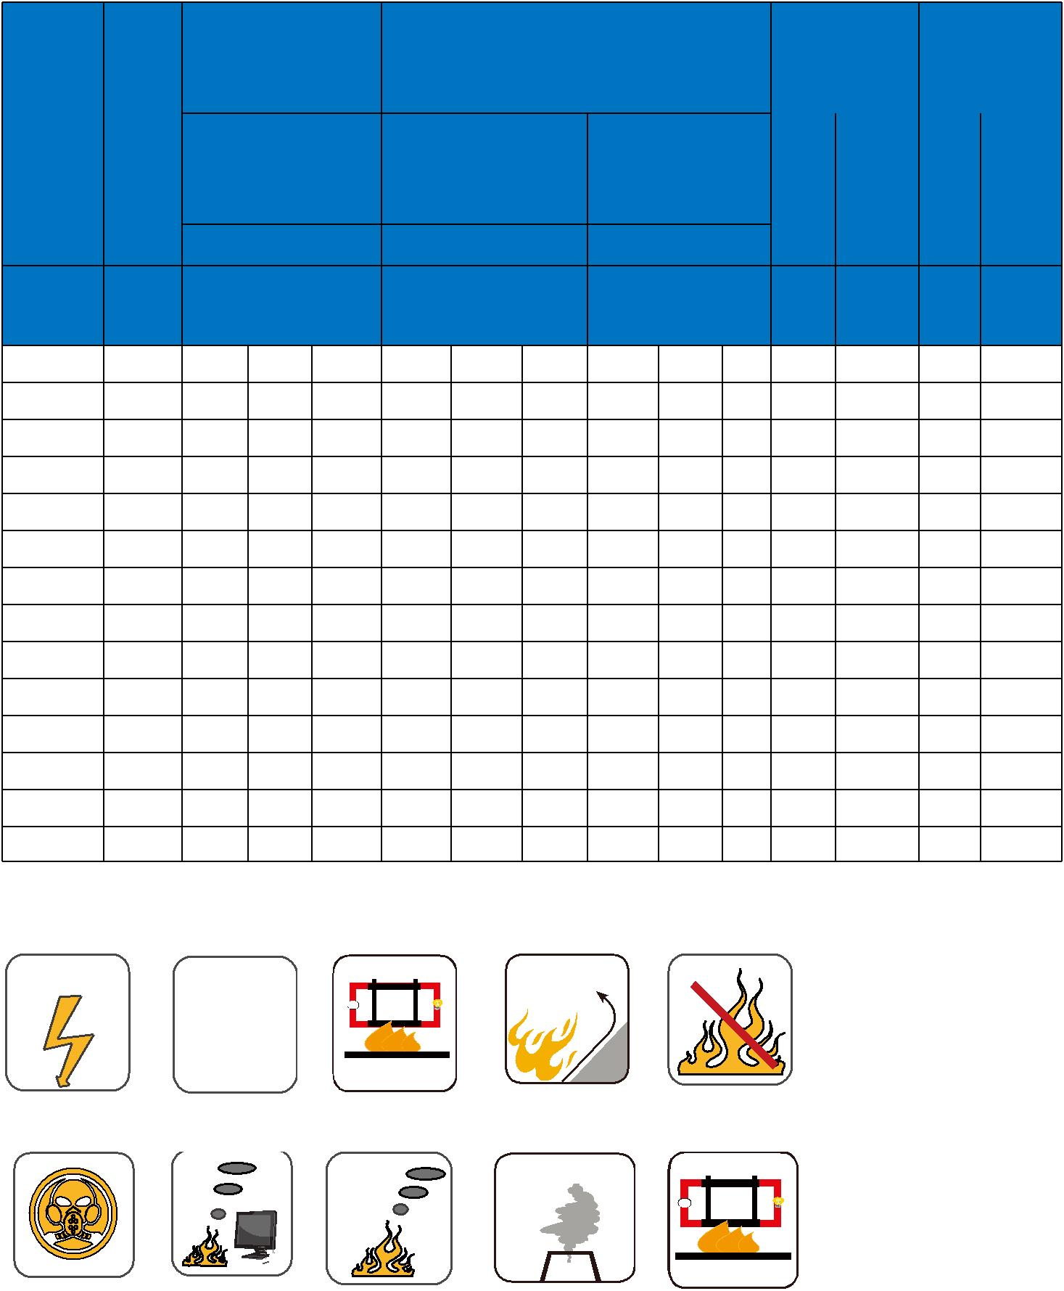

 ADDISON 39

